

**LoRaWAN Gateway and Wireless Sensor User Guide**

**Version:** V1.2

**Date:** 2019-11-11

# Table of Contents

Table of Contents 2

1 Product Introduction 4

2 Quick Start 8

3 Device Installation 9

3.1 Part List 10

3.1.1 Gateway Part List 10

3.1.2 Sensor Node Part List 11

3.1.3 Other Accessories & Tool List 11

3.2 Gateway Installation 12

3.2.1 Gateway Installation Methods 12

3.2.2 Installation Environment Considerations 13

3.2.3 Install SIM Card 14

3.2.4 Connecting to Ethernet Cable 15

3.2.5 Installing 4G Antenna 15

3.2.6 Installing LoRa Antenna 16

3.2.7 Installing Ground Cable 17

3.2.8 Connecting to Power Cable 18

3.3 Installing Sensor Node 19

3.3.1 Power On 19

3.3.2 Installing the Sensor Node Bracket 20

3.3.3 Installing Sensor Nodes 21

3.3.4 Dos and Don’ts in Installing Sensor Probes 22

4 Network Configuration 24

4.1 Gateway Network Configuration 25

4.1.1 Connecting to Ethernet 25

4.1.2 Connecting to 4G 26

4.2 Device Status Check, Dos & Don’ts 27

4.2.1 Checking Gateway Connection Status 27

4.2.2 Sensor Node Working Status 27

4.2.3 Booting and Rebooting Sensor Nodes 28

4.2.4 Checking Sensor Node Data Connection to the Cloud 28

5 SenseCAP Portal 30

5.1 Explanation of Terms and Tags 31

5.2 Account and Login 32

5.3 Dashboard 34

5.3.1 Configure Scene 34

5.3.2 Configure Charts 35

5.4 Device Management 37

5.4.1 Gateway 37

5.4.2 Node Group Management 37

5.4.3 Sensor Node Management 38

5.5 Data Management 40

5.6 Security 42

5.6.1 Check Account Info 42

5.6.2 Access Key Management 42

6 SenseCAP App Instructions 43

6.1 Download SenseCAP App 44

6.2 Bind Devices 45

6.2.1 Group Management 46

6.2.2 Check Groups 46

6.2.3 Create New Groups 46

6.3 Device Management 48

6.3.1 Check Device 48

6.3.2 Device Details 48

6.4 User Profile 50

6.4.1 Check Current Account 50

6.4.2 Settings 50

6.4.3 Sign Out 50

7 API Instruction 51

# Product Introduction

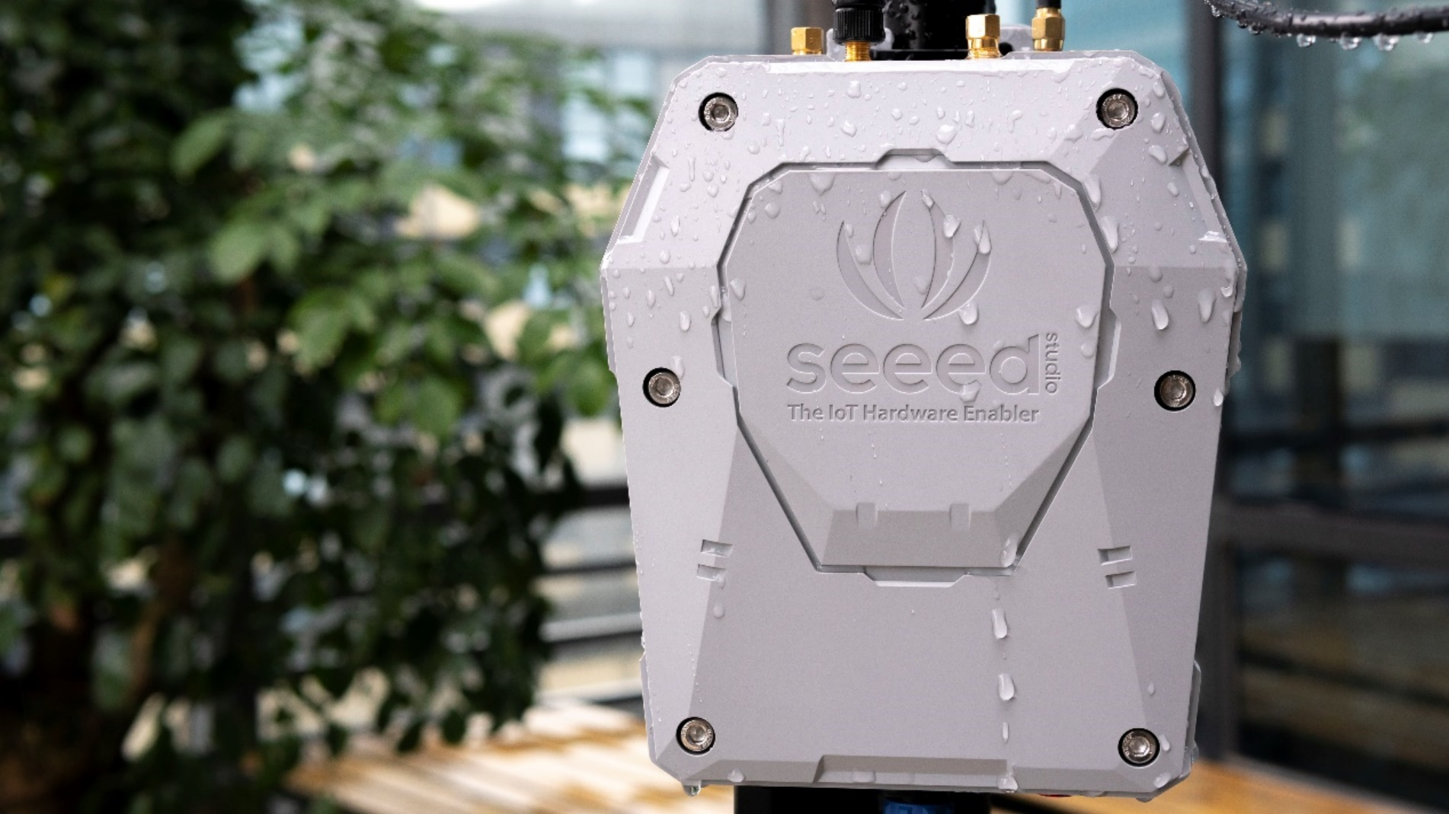

SenseCAP is an industrial wireless sensor network that integrates easy-to-deploy hardware and data API services, enabling low-power, long-distance environmental data collection. SenseCAP includes several versions, such as LoRaWAN, NB-IoT, etc.

SenseCAP LoRaWAN version products include LoRaWAN Gateways and Sensor Nodes. Based on the LoRaWAN protocol, it can realize one-to-many, long-distance networking and bilateral communication. The LoRaWAN Gateway supports Ethernet and 4G. The Sensor Node is powered by a high-capacity battery that lasts up to 3 years (if uploading data once every hour). It also supports hot-swap, making it easy for maintenance and upgrading.

SenseCAP provides an easy-to-use cloud platform. Users can scan the QR code with the SenseCAP App to bind the device with its respective account to manage the devices, and check Sensor Node data on the SenseCAP Portal. SenseCAP Portal provides API for users to further develop based on the data on the Portal.

**Main Features:**

* Gateway: High-performance Cortex A8 1GHz processor
* Sensors support LoRaWAN protocol, ultra-low-power consumption, battery lasts for 3 years (if upload data once every hour)
* Gateway uses multiple methods to connect to the network: 4G and Ethernet to support different scenarios
* Super long-distance communication: 10km in line-of-sight scenario, 2km in urban scenario
* Easy-to-use cloud platform and API
* Industrial protection rating IP66-rated enclosure, suitable for outdoor environment at -40℃~70℃
* Easy-to-deploy, enabling people without engineering background to install the devices quickly
* Modular design for the Sensor Nodes, including a Sensor Node Controller and a Sensor Probe, with a specially-designed bracket for easy installation on poles or walls.

**LoRaWAN Gateway:**

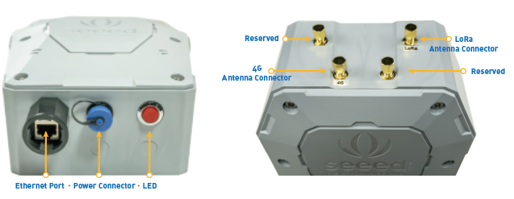

At the bottom of the gateway are Ethernet port and power connector, all of which meet the waterproof requirements. LED indicator light indicates the networking status. The top of the gateway is the connector for installing 4G/LoRa antenna, and the other connectors are reserved.

**LoRaWAN Sensor Node:**

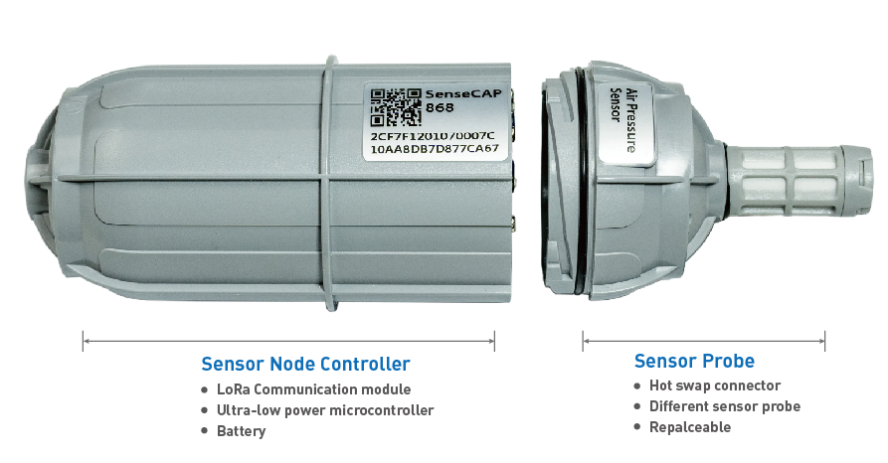

Snap to open the device and you will see two parts. The Sensor Node Controller’s circuit shows a power switch, a RESET button, and an indicator LED as well as a mode button and serial ports, which will be used for firmware upgrading. The two parts connect and communicate via two spring connectors.

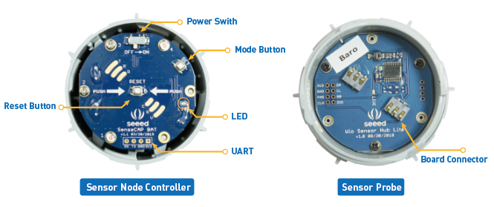

Each Sensor Node comes with a bracket for easy installation on a pole or wall.

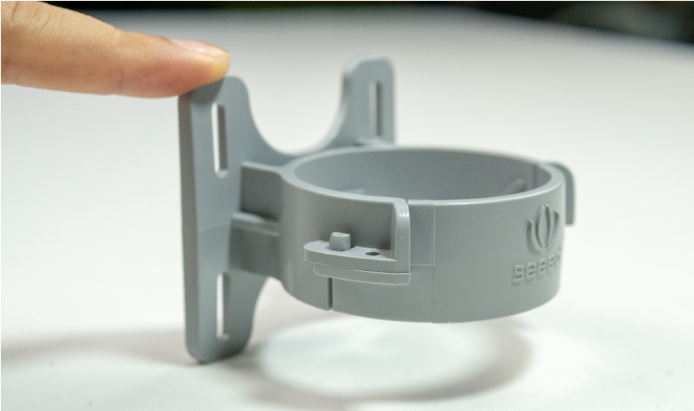 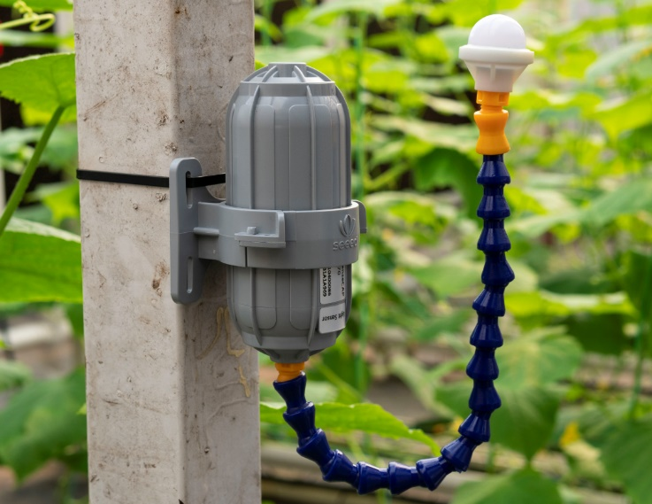

**SenseCAP Portal：**

SenseCAP Portal provides multiple services, including web-based management portal and API for calling data. Users can further develop system integration with the API, without worrying about embedded hardware technologies, hence shorten the development cycle.

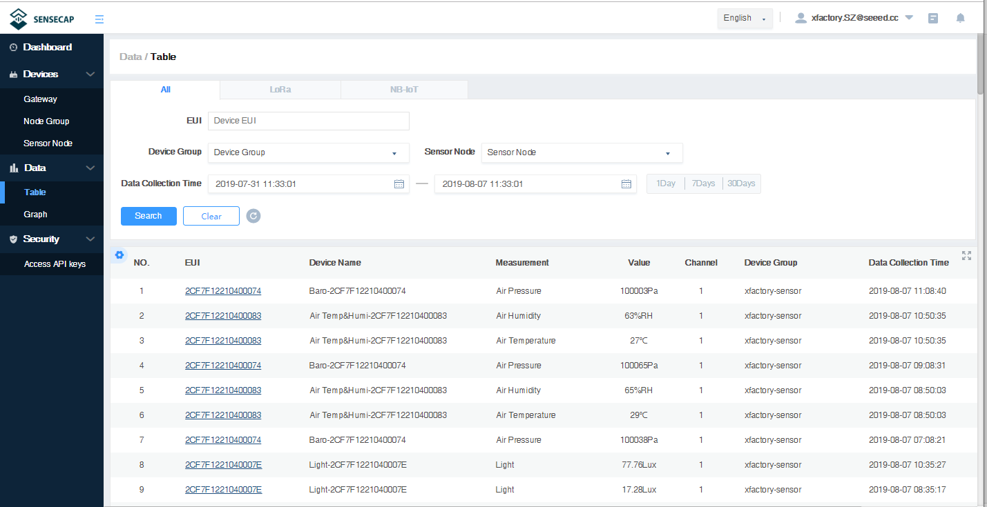

# Quick Start

The main steps are listed for quick use. Please refer to the following section for more details.

1. **Check list.**

Unpack the package, check the list of devices, and check whether there are any omissions.

1. **Assemble the gateway.**
2. Install LoRa and 4G antennas.
3. Connect to Internet (use Ethernet or install 4G card).
4. Connect the power supply.
5. **Power on the gateway.**
6. The LED indicator light will turn off after 2 seconds and the gateway will start normally.
7. Wait for about 1 minute, LED indicator light starts flashing, indicating that the device is trying to connect to the Internet.
8. The LED indicator light is always on, indicating that the gateway is connected to Internet successfully.
9. **Creating Groups and binding devices.**
10. Register SenseCAP Portal accounts and create Node Groups: station-1, station-2, station-3…
11. Bind the Gateway and Sensor Node by scanning QR code or manually entering EUI through SenseCAP App, and bind the nodes to specific Node Groups.
12. Switch ON the Sensor Node, turn on the sensor probe, turn on the power switch to the "ON", and the LED light will flicker once, indicating that power on successfully. Wait for about 10s, and the LED light flashes quickly for 2s, indicating that the device is connected to the network successfully.
13. Repeat steps 2) ~ 3) put all sensors into the network.
14. Check the data on the SenseCAP Portal, confirm that all sensors are online and upload the data normally.
15. **Install devices.**
16. Determine the actual installation location of devices.
17. Install poles, brackets and other accessories.
18. Install the gateway and sensor to the corresponding monitoring station.

# Device Installation

In this chapter, we will introduce the gateway and sensor nodes, their respective installation processes, as well as the dos and don’ts. Before installing, please check the part list to ensure nothing is missing.

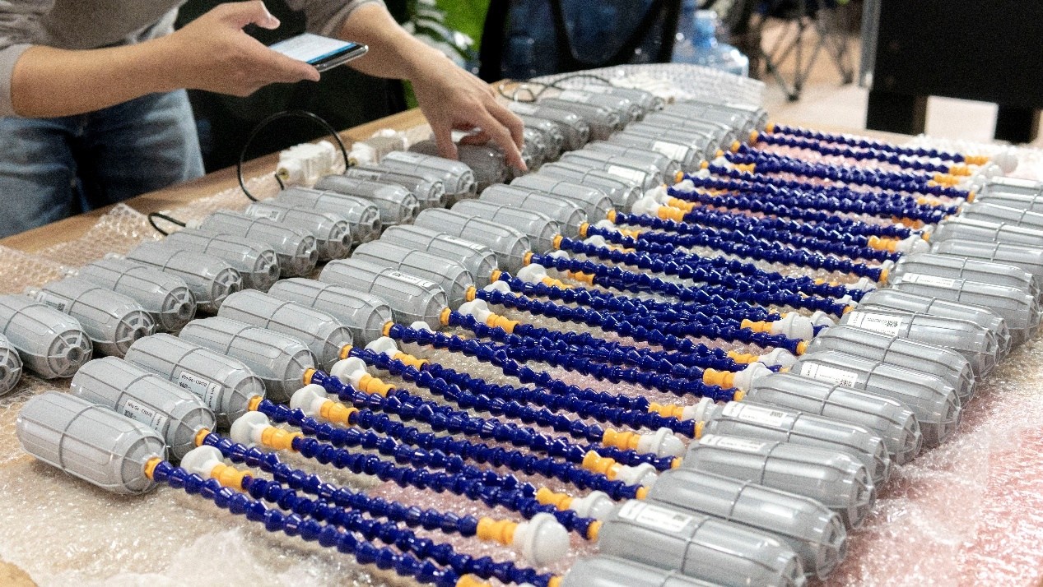

## Part List

### Gateway Part List

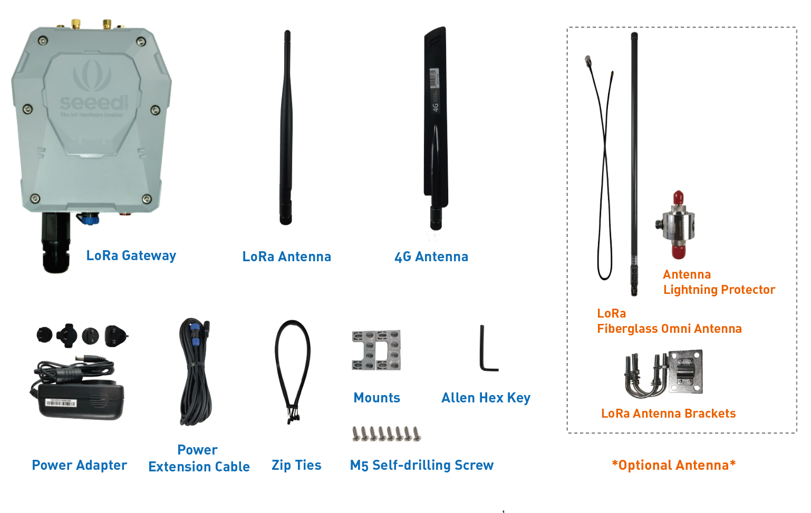

The LoRa Gateway comes with a standard antenna. If you need ultra-long-distance communication, you will need to purchase a high-gain fiberglass antenna.

|  |  |  |
| --- | --- | --- |
| **Item** | **Name** | **Quantity** |
| 1 | LoRa Gateway | 1 |
| 2 | LoRa Antenna | 1 |
| 3 | 4G Antenna | 1 |
| 4 | Power Adapter | 1 |
| 5 | Power Extension Cable (5M) | 1 |
| 6 | Zip Ties | 2 |
| 7 | Mounts | 4 |
| 8 | M5 Self-drilling Screw | 8 |
| 9 | Allen Hex Key | 1 |
| 10 | Antenna Lightning Protector (*Optional) | 1 |
| 11 | LoRa Fiberglass Omni Antenna (*Optional) | 1 |
| 12 | LoRa Antenna Brackets (*Optional) | 1 |

### Sensor Node Part List

The accessories for different sensors may vary. The common parts are as follows:

|  |  |  |
| --- | --- | --- |
| **Item** | **Name** | **Quantity** |
| 1 | Sensor | 1 |
| 2 | Bracket | 1 |
| 3 | M4 Self-drilling Screw | 4 |
| 4 | M3 Self-drilling Screw | 2 |

### Other Accessories & Tool List

For installing in different scenarios, you might need to purchase extra accessories or tools.

|  |  |  |
| --- | --- | --- |
| **Item** | **Name** | **Quantity** |
| 1 | GND Copper Wire (2.5mm2) | 2 |
| 2 | Pliers | 1 |
| 3 | M4x12 Grounding Screw | 1 |
| 4 | Waterproof Self-adhesive Tape (to protect antenna connection part) | 1 |
| 5 | M6 Self-drilling Screw (to install the gateway on the wall) | 4 |

## Gateway Installation

### Gateway Installation Methods

* **Installing on a pole (recommended)**

Firstly, use M5 self-drilling screws (included in the package) to fasten the 4 brackets onto the gateway. And then use cable ties to fasten the gateway onto the pole. Recommended pole diameter is 70mm.

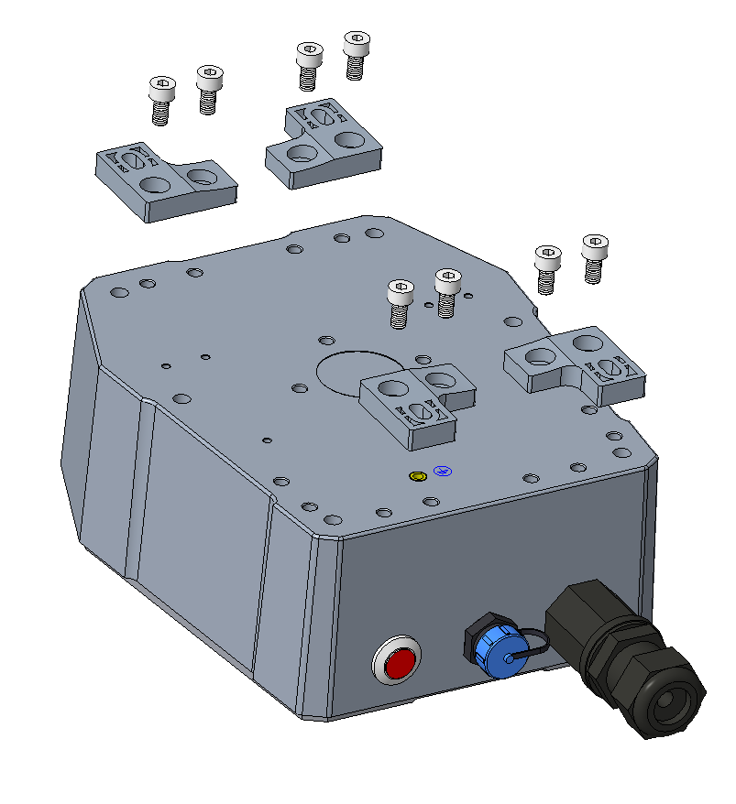 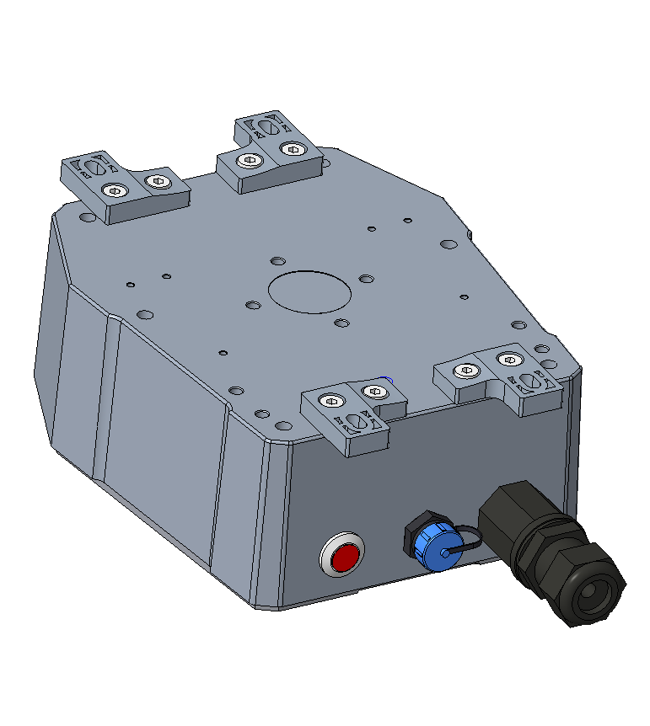

Put cable ties through the holes of the bracket and pull to fasten onto the pole. To get better communication range, it is recommended to mount the gateway 3 meters above the ground. If there are tall buildings around, the gateway should be kept away from the building or mounted on top of the tall building.

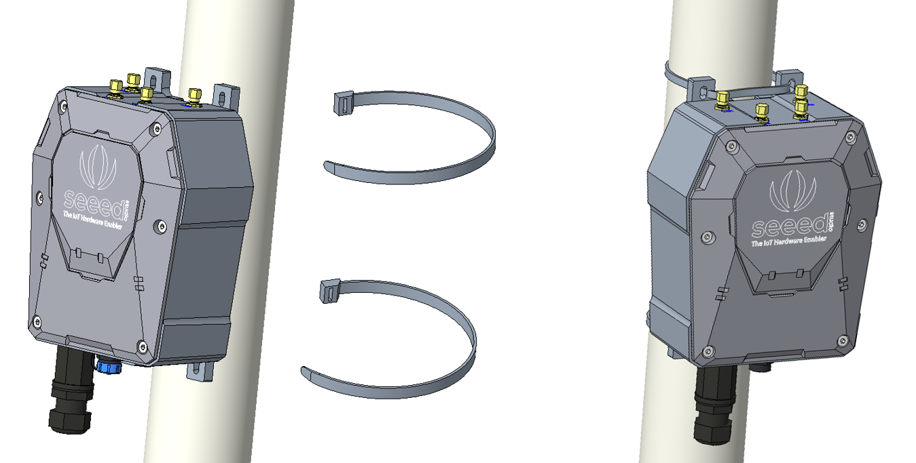

|  |
| --- |
| **Note:** If the pole is made of metal, the antenna should be pulled higher than the metallic part of the pole, or the communication signal will be interfered. |

* **Installing on the Wall**

Firstly, use M5 self-drilling screws (included) to fasten the 4 brackets onto the enclosure of the gateway (refer to the image below for directions). And then fasten the gateway onto the wall with screws.

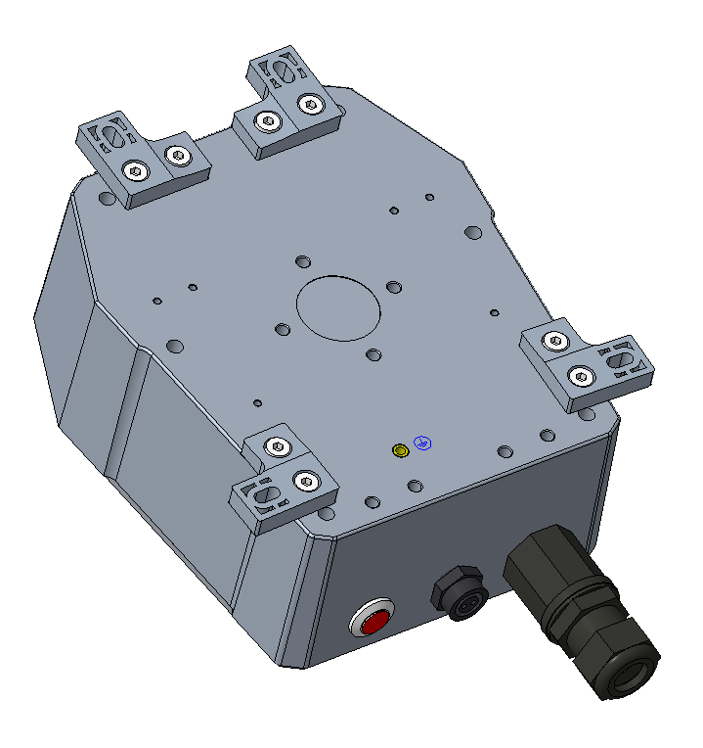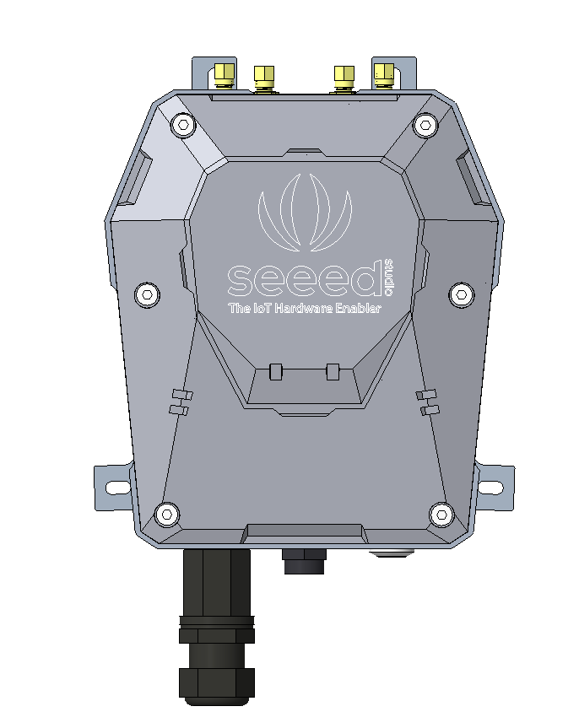 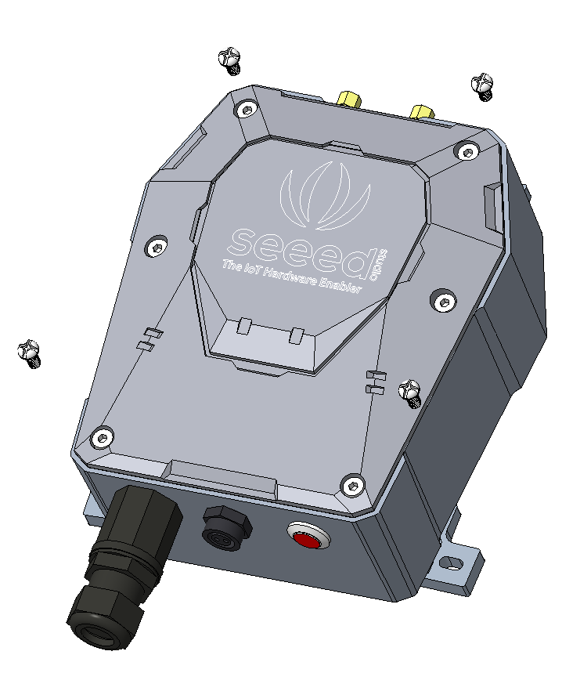

|  |
| --- |
| **Note:** The screws (that fasten gateway onto the wall) are not included in the package. Please prepare screws according to the wall materials (recommended screw diameter: 6mm). |

### Installation Precautions

1. In mountainous or thunderstorm-stricken areas, please take lightening protection measures. For fiberglass LoRa antenna, you will need to install a lightening arrester and make sure it is connected to the ground. In addition, the gateway should be mounted lower than the lightening rod.
2. 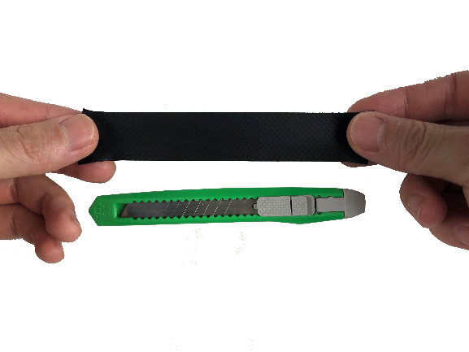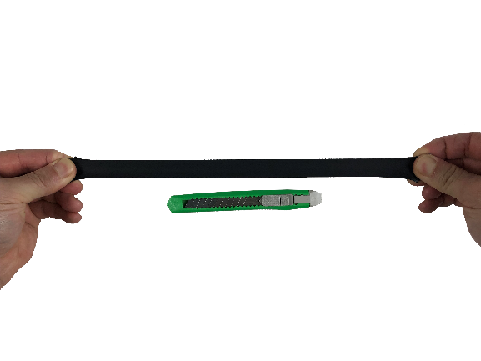When installing the gateway in outdoor environment, the connected part should be protected with waterproof tape, to enhance waterproof performance and lengthen device lifespan. As shown below, use self-adhesive tape to protect the connection. Take a rubber tape at the length of 10cm ~ 15cm, pull it to twice of that length

wind the tape clockwise to the connected part of the antenna.

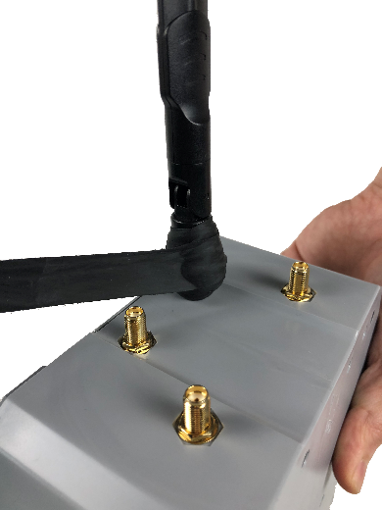 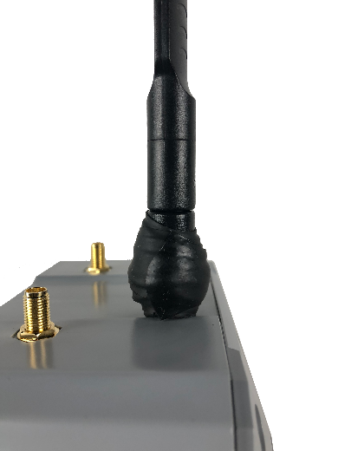

|  |
| --- |
| **Note:** The tape must be wound clockwise, because the antenna is fastened clockwise. Otherwise, the antenna may loosen. |

If the sensor has wires, install threaded tubes:

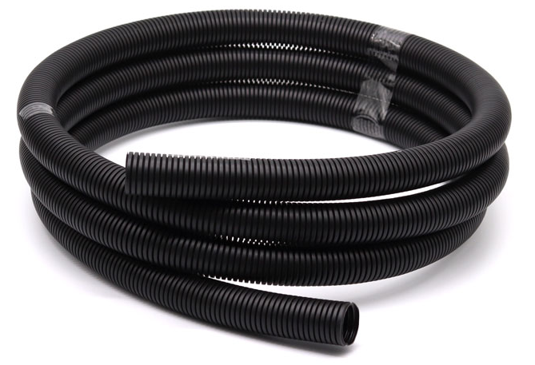

### Install SIM Card

* Use the hex key (included in the package) to unscrew the 6 screws and open the lid.

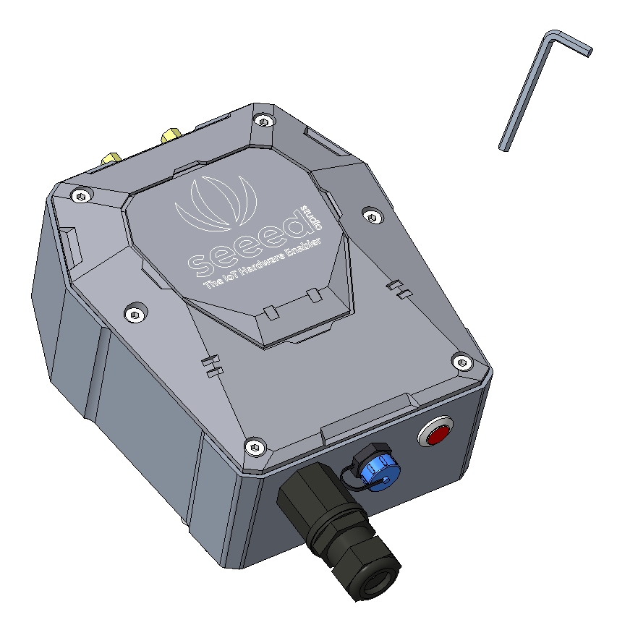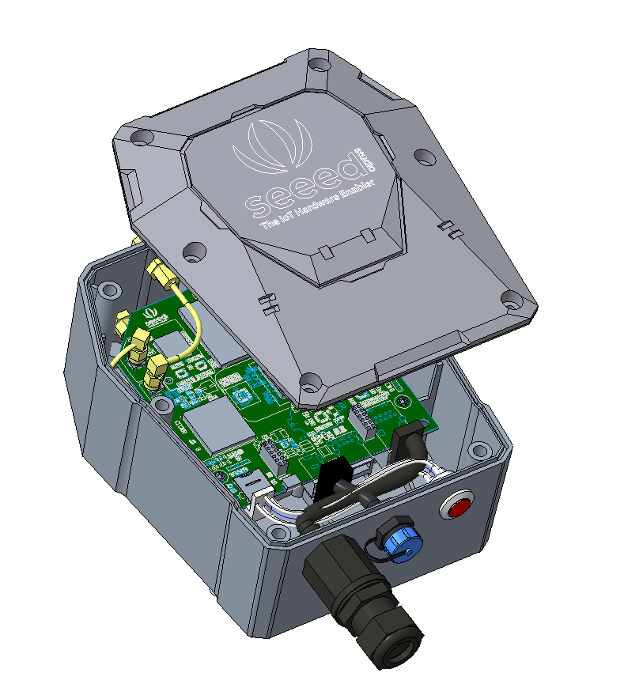

* Swipe downward to open the SIM card socket, insert the Micro SIM card and swipe upward to lock the SIM card socket. Make sure it is installed correctly and close the lid with the screws.

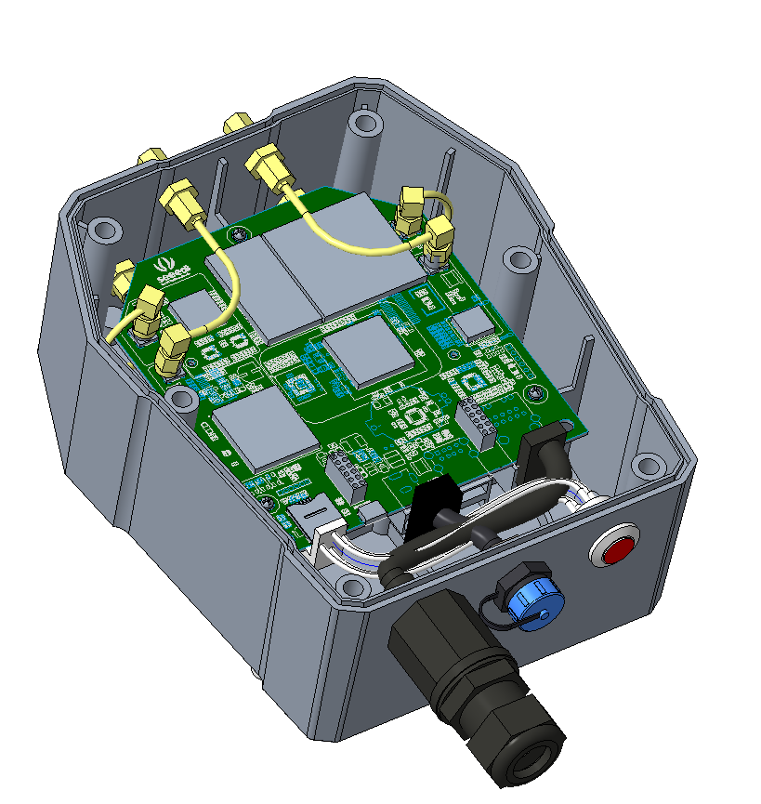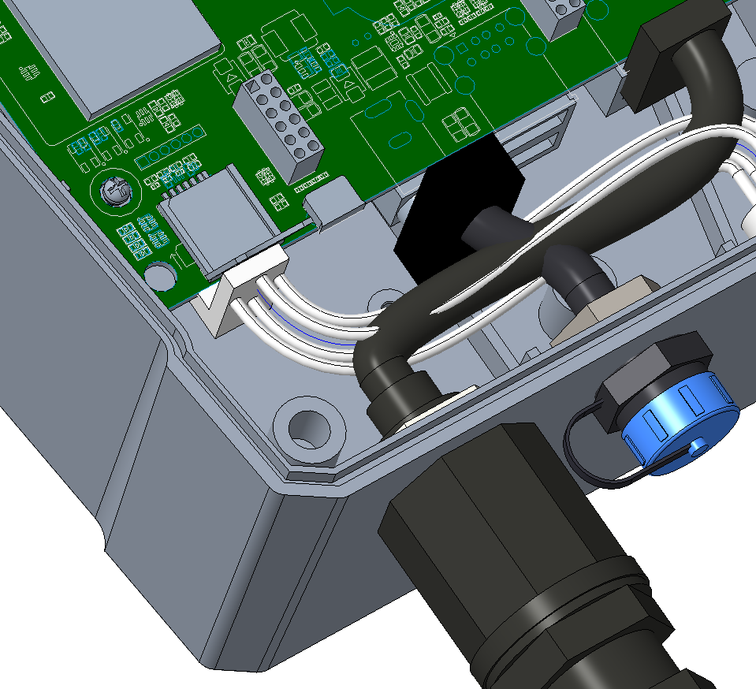

### Connecting to Ethernet Cable

Unscrew to open the protection cap, plug the Ethernet cable through the cap and then into the Ethernet port. Screw to fasten this part.

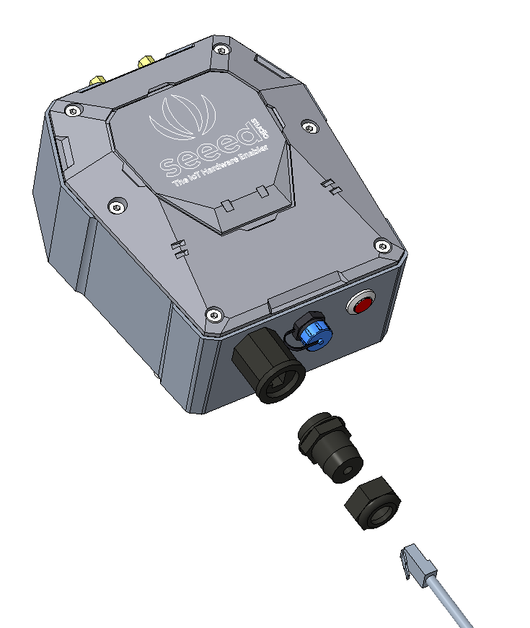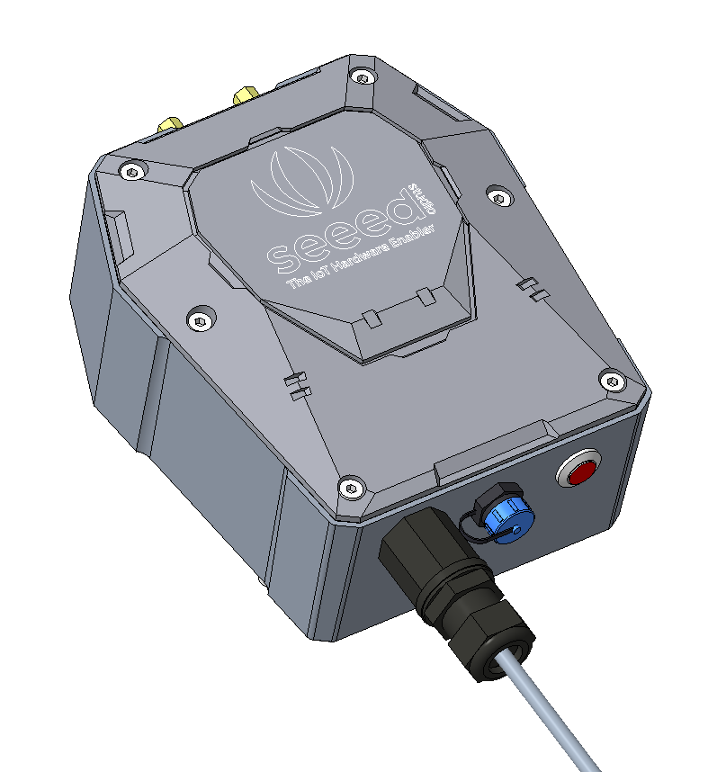

### Installing 4G Antenna

Unscrew to remove the copper cap on the 4G antenna port, and screw clockwise to install the 4G antenna onto the gateway.

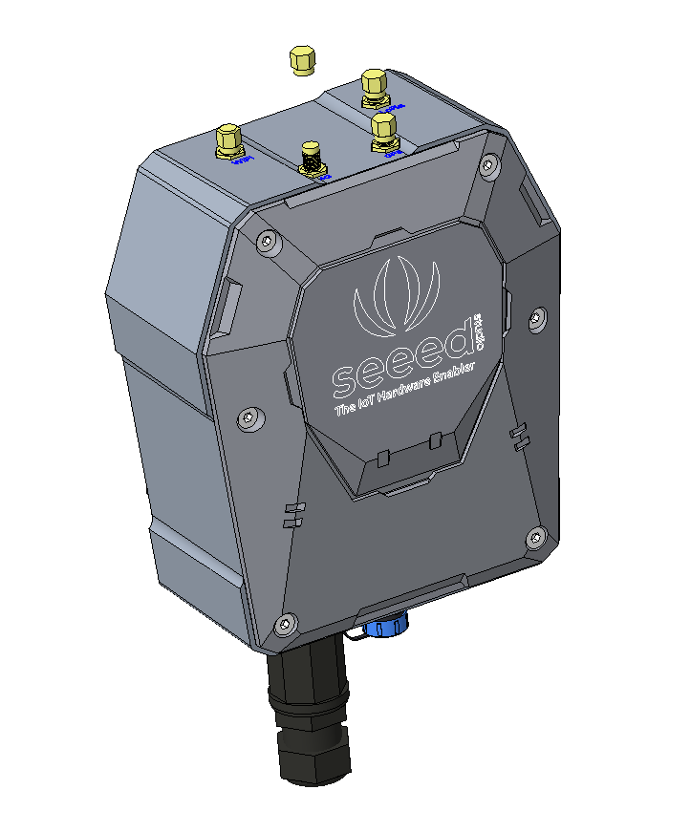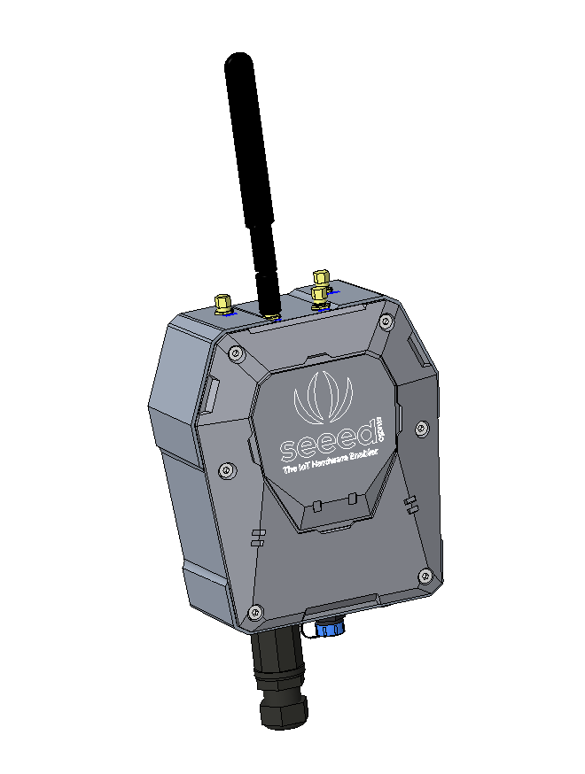

|  |
| --- |
| **Note:** When installing the antenna, do not connect the power supply, otherwise it will cause damage to the antenna circuit! |

### Installing LoRa Antenna

There are two kinds of LoRa antennas: the normal LoRa antenna (included in the package), and the fiberglass LoRa antenna (to be purchased separately). The installation method for normal LoRa antenna is the same as that of 4G antenna. Here we will introduce how to install the fiberglass LoRa antenna.

1. Unscrew to remove the copper cap on the LoRa antenna port, and fasten the lightening arrester onto the antenna port.

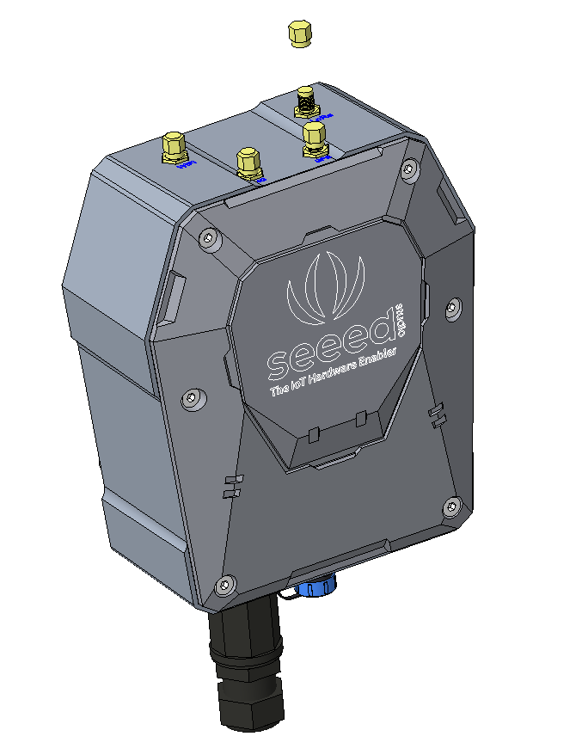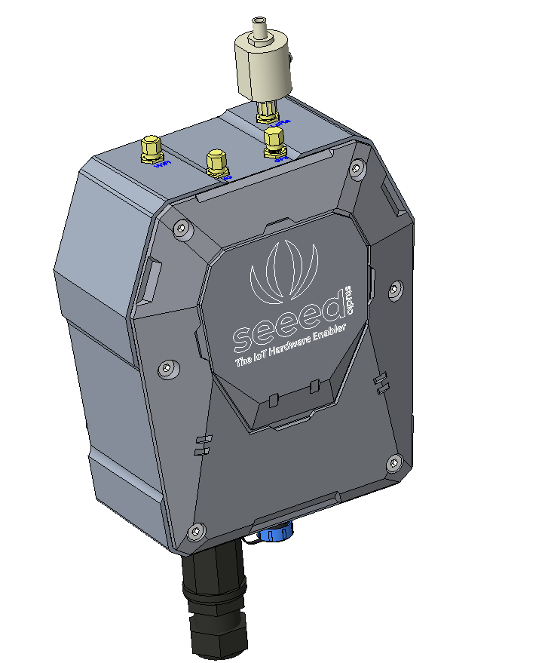

1. As shown in the image below, please fasten the fiberglass antenna onto the base part, and then fasten the whole part onto the vertical cylinder (maximum cylinder diameter: 50mm).

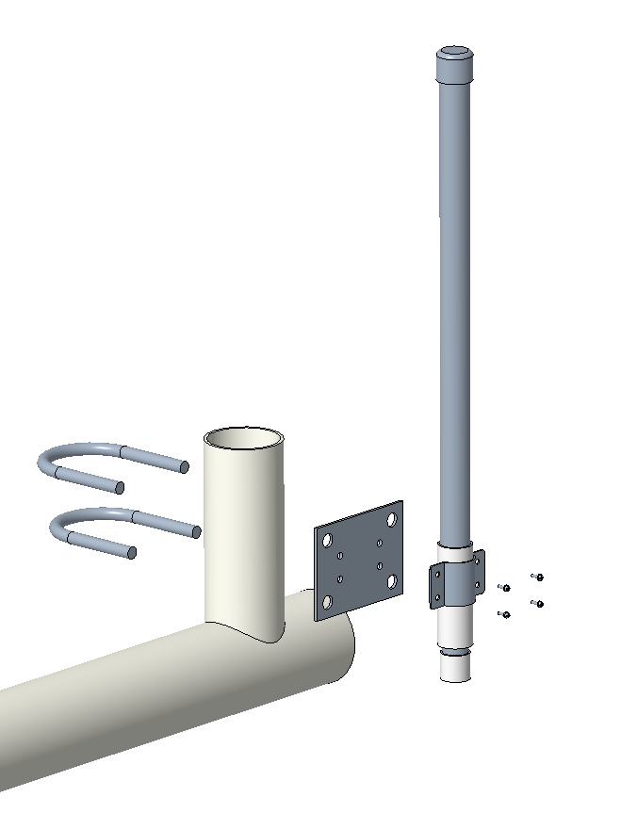

1. Use a 1-meter antenna feed line to connect the lightening arrester with the fiberglass antenna.

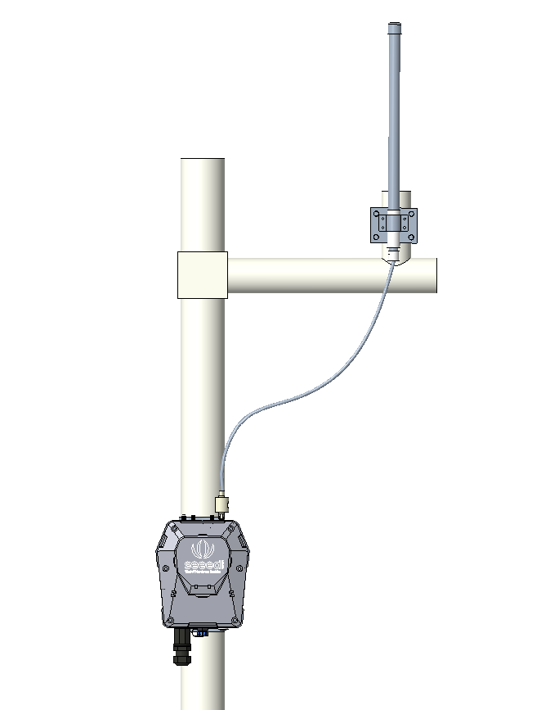

### Installing Ground Cable

Here we will connect the lightening arrester to the GND screw port on the gateway with a ground cable, and then connect the whole device to the ground. The image below shows the location of the GND port at the backside of the gateway.

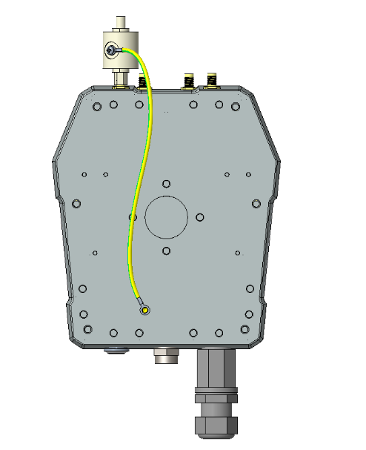 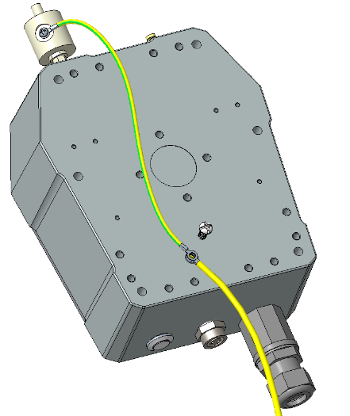

Gateway's ground

screw port

**2**

**1**

1. Prepare two copper cables, a shorter one (approx. 30cm) for connecting the lightening arrester with the GND screw port (on the gateway), and a longer one for connecting the device to the ground.
2. Fasten the lightening arrester to the short copper cable with screws, and then connect the two copper cables to the GND screw port. Use screw to connect and fasten them.
3. Once the two cables are connected, connect the other end of the long cable to the ground. Depending on your actual installation environment, you can connect it to the ground directly or connect it to the copper ground bars.

### Connecting to Power Cable

Unscrew to take off the power cap, plug in the extension cord and screw to fasten it onto the gateway. The other end of the extension cord is connected to the power adapter.

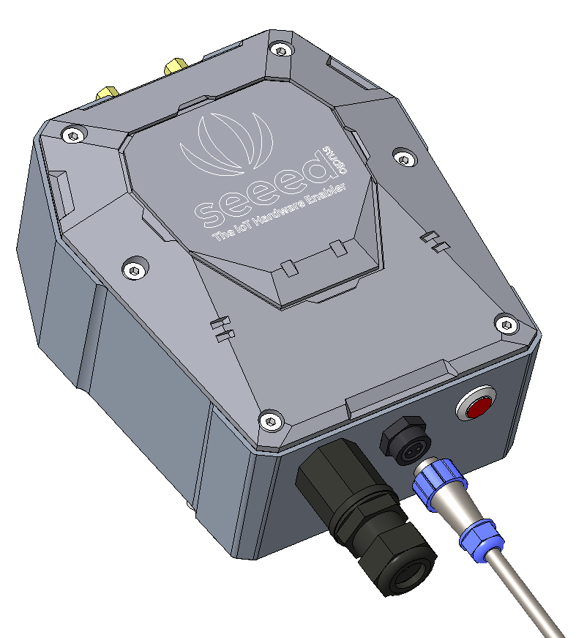

## Installing Sensor Node

### Power On

The power switch is hidden inside the device. Open the device and turn on the power before installing the sensors. Here is the step-by-step instruction:

1. Loosen the Sensor Probe by turning the cap counterclockwise. Use the white cap opener to make this process easier. The image below uses TH Sensor as an example and applies to all other SenseCAP sensors.

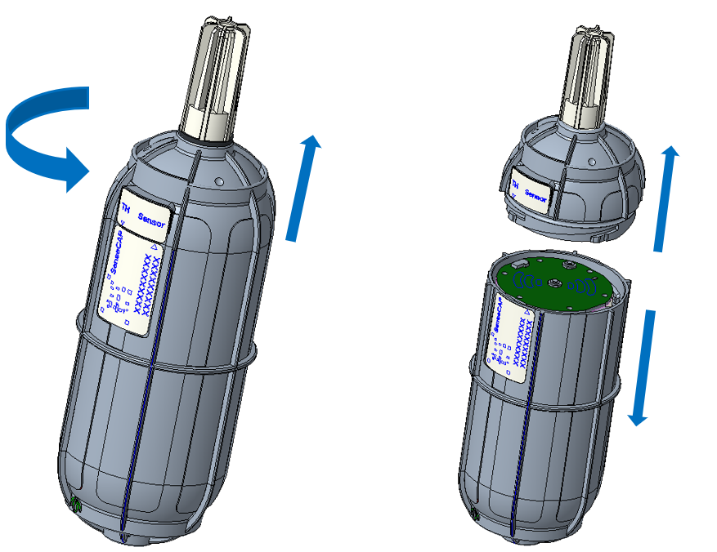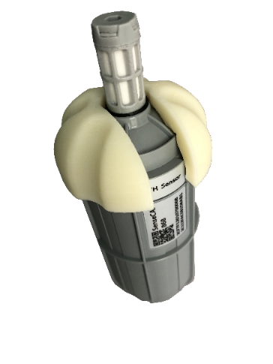

1. After opening the device, turn the switch to “ON”, and the LED on the lower right corner will flash, indicating that the power is on. Wait for about 10 seconds, then the LED will flash quickly for 2 seconds, indicating that the device is connected to the network.

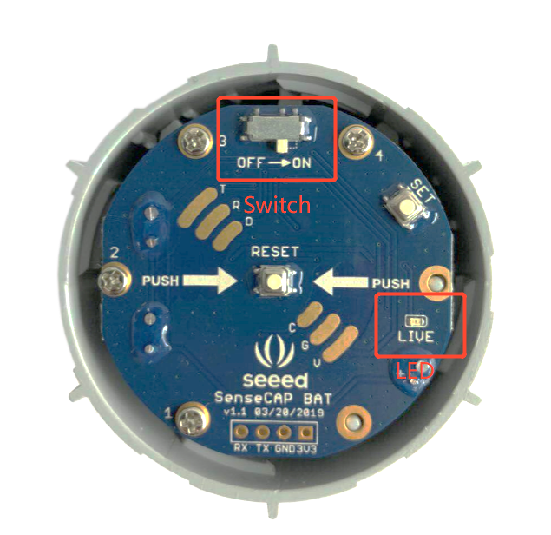

1. After the device is connected to the network, connect the Sensor Probe back with the Sensor Node Controller by turning it clockwise. Please note that the labels on both parts should be aligned as show in the image below, otherwise the two parts will not be attached to function properly and data will not be uploaded.

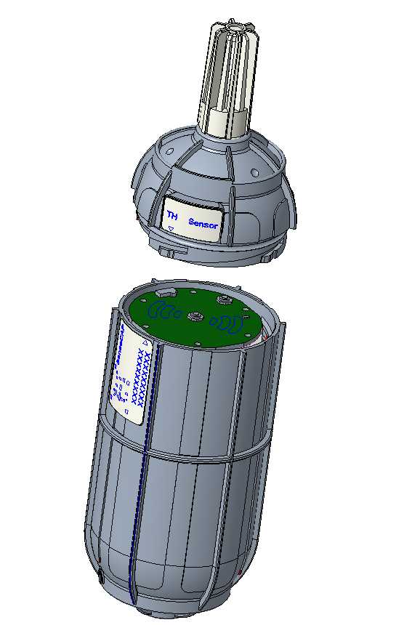

### Installing the Sensor Node Bracket

Specially designed for installing SenseCAP Sensor Nodes, the bracket consist of a bracket and a sliding cap. With designated screw-holes, the bracket helps fasten the Sensor Node firmly onto a pole or a wall.

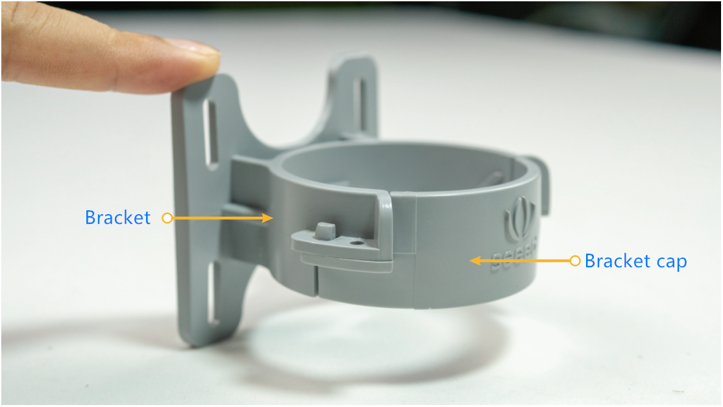

1. To install on a pole, you can use zip ties to fasten the bracket (recommended pole dimension is 50-70mm in diameter). Please refer to the following image for bracket directions.

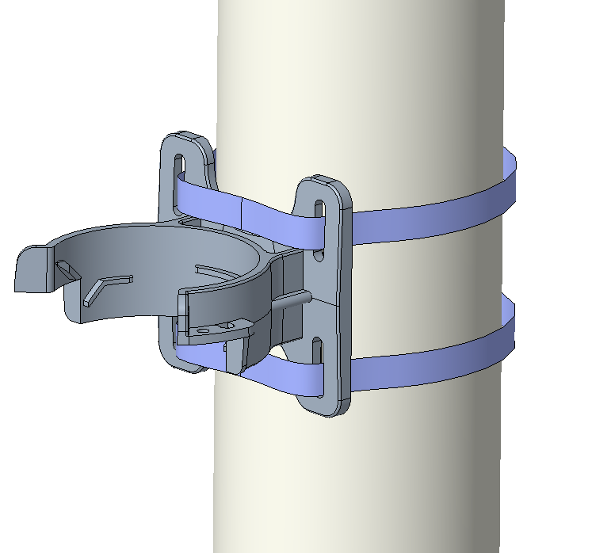

1. To install on the wall or other surfaces, you can use self-drilling screws to fasten the bracket onto the surface.

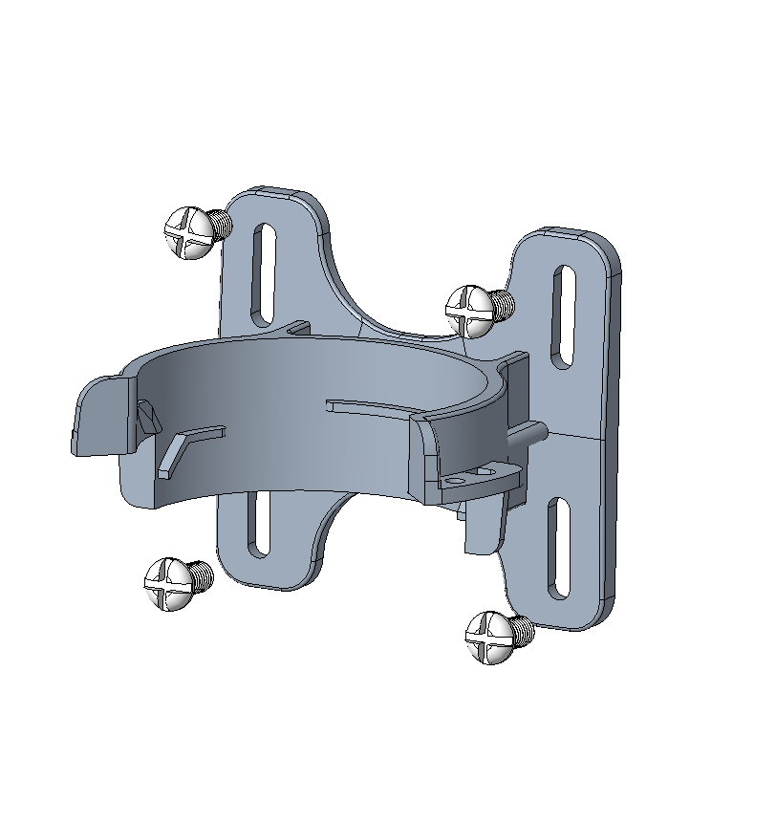

### Installing Sensor Nodes

After installing brackets, let’s install sensors.

1. The Sensor Probe should be placed vertically downward with the label facing outward. Be consistent with the bracket gap. Make sure the circle part in the middle of Sensor Node is aligned with the middle of the bracket, and then press the Sensor Node to fit into the bracket. A click/snap sound indicates that the Sensor Node has been installed successfully. Try to manually twist it to make sure the Sensor Node is locked to the bracket securely.
2. Secure by fastening the bracket cap as instructed in the image.
3. Place two self-drilling screws on the bracket to increase firmness and help prevent theft.

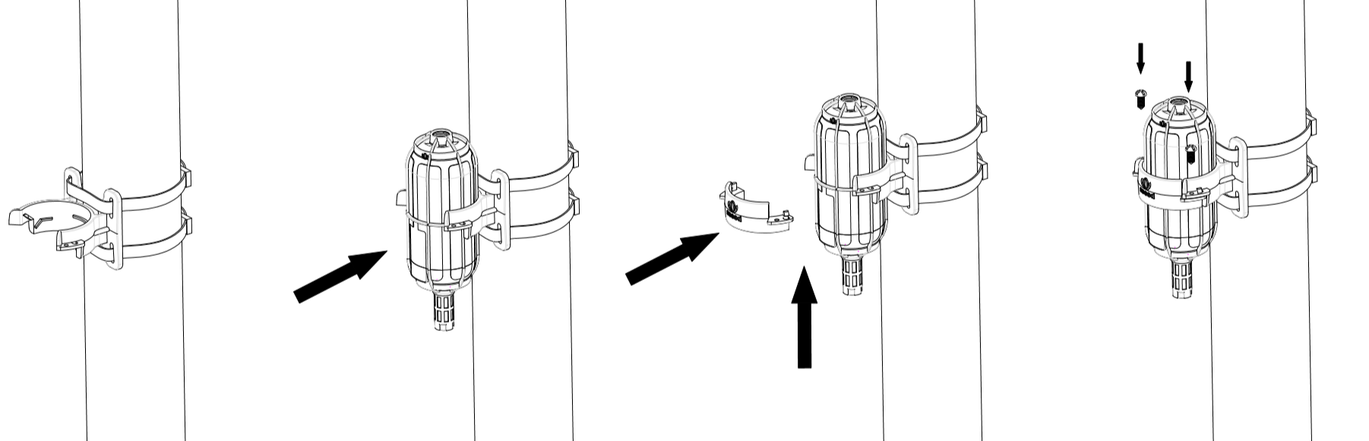

|  |
| --- |
| **Note：**Do not insert the Sensor Node into the bracket from the top, or it will not fasten the onto the bracket securely. |

### Dos and Don’ts in Installing Sensor Probes

The same instruction applies for installing the different Sensor Nodes. However, there are some tips to keep in mind when installing certain Sensor Nodes.

* **Light Sensor**

The Sensor Probe of the Light Sensor needs to be placed vertically upward, and there should not be anything obstructing sunlight from the Sensor Probe.

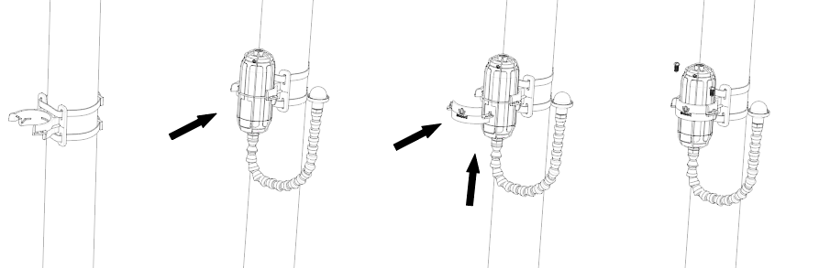

* **CO2 Sensor**

The Sensor Probe can be fastened with self-drilling screws. Please refer to the image below for probe direction. The end without the cables should point downward to prevent rain or dust from getting into the probe. Also, the device should be in a place with good ventilation. 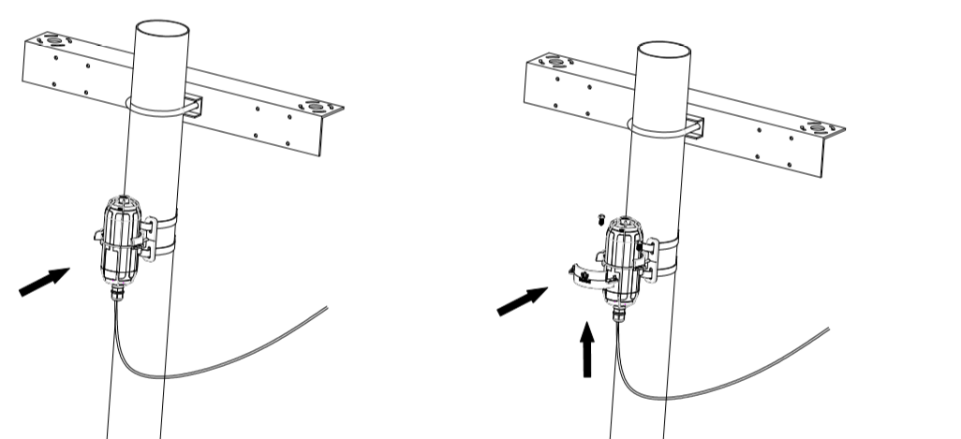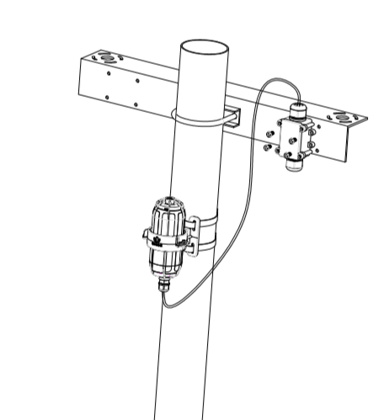

# Network Configuration

After installing the device, you need to test and configure the network. If the device is to be installed in a high place, you can also test and set up the network connection before installing.

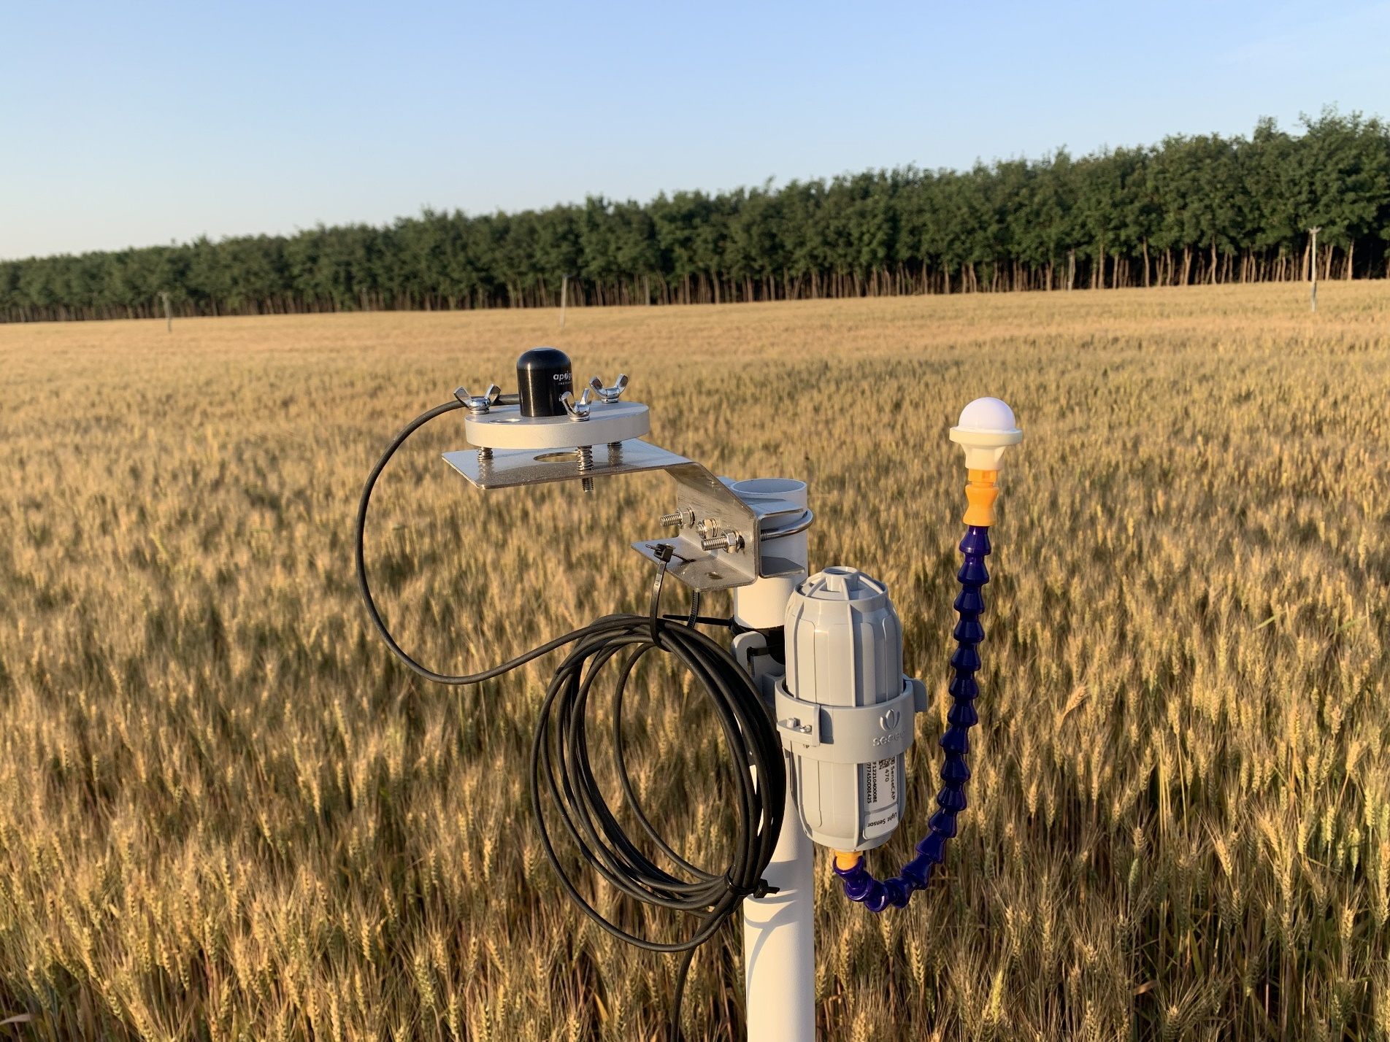

## Gateway Network Configuration

Make sure all antennas are correctly installed before powering on the gateway. Please note the device should be POWERED OFF when installing the antenna, or the antenna circuits might be damaged.

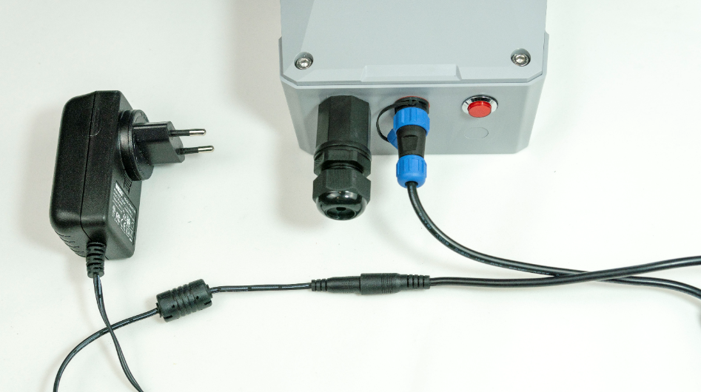

### Connecting to Ethernet

Please refer to previous chapter to connect the gateway to the Ethernet cable and power cable. Power on the gateway and wait for 1~2 minutes. When the light is on, it indicates that the gateway is connected to the network successfully.

Please see below for different indicator statuses.

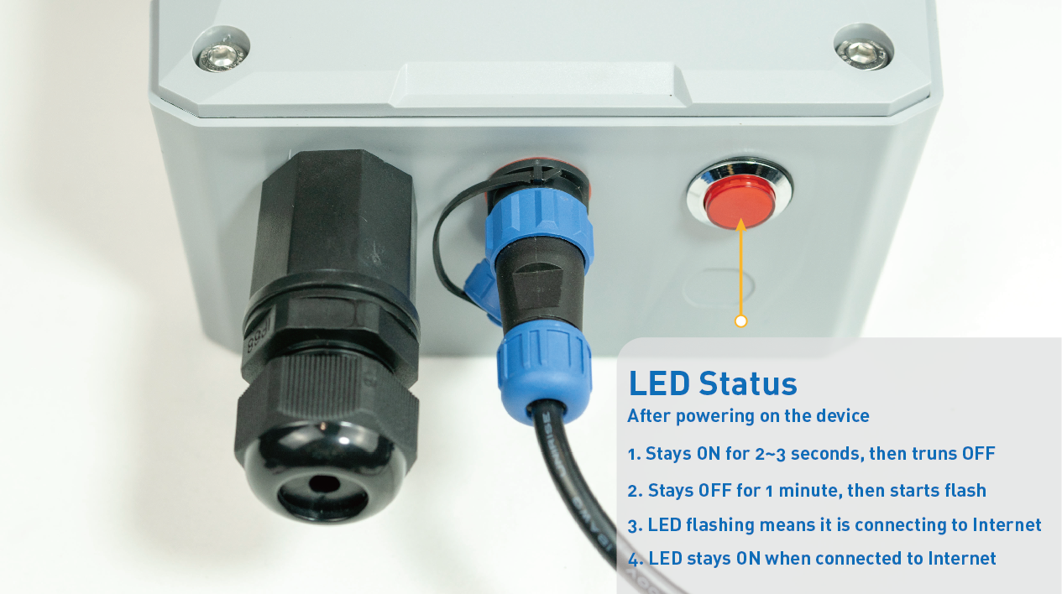

### Connecting to 4G

Please refer to previous chapter to install SIM card. Please make sure it is a 4G SIM card because the device only supports 4G network. Then connect the gateway to the Ethernet cable and power cable. Power on the gateway. The process and LED indications are the same as connecting to Ethernet (as shown above).

|  |
| --- |
| **Note:** Select a way to access the Internet. If cable network is selected, please take out 4G card. If you choose 4G network, do not connect to Ethernet. Because when the network is unstable, it may cause conflicts, resulting in abnormal networking. |

## Device Status Check, Dos & Don’ts

### Checking Gateway Connection Status

After powering on the gateway, you can check gateway working status through the following methods:

* **Light Indicator**: ON means the gateway is connected and in working condition, flashing means network latency or no connection. When the connection resumes, the indicator will be ON.
* **App**: In the SenseCAP App, “Online status” indicates “Online” when the gateway is connected to the network and can receive and transfer sensor data. Please refer to Chapter 6 for obtaining the SenseCAP App.

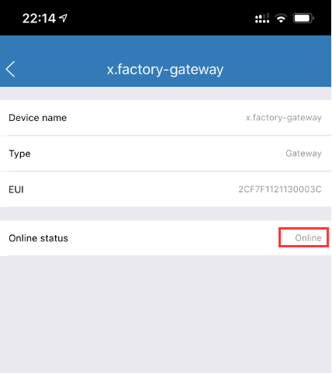

### Sensor Node Working Status

You can refer to the LED indicator for the Sensor Node for its working status. Please see the status explanations in the image below:

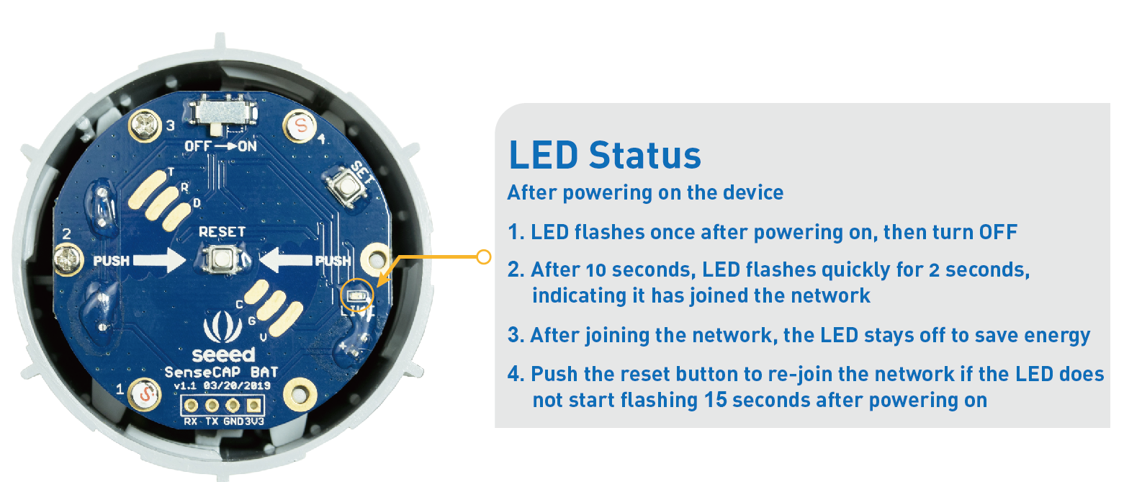

|  |
| --- |
| **Note:**   1. Each device will constantly sync with the cloud within 1 minute of connecting to the network. This process takes up LoRa communication channel. When multiple devices are powered on and connected to the network at the same time, it might congest the LoRa network, leading to failure to access the network. Hence, we suggest that you wait one minute after turning on one Sensor Node to turn on the next one. 2. If repeated network access is not successful, please check whether the gateway power is normal, and then check whether the gateway network is normal. Please email sensecap@seeed.cc. We will deal with it in time. |

### Booting and Rebooting Sensor Nodes

To reboot the device, we’d suggest you use the “RESET” button instead of flipping the power switch. When using the power switch to reboot the device, please turn off the device and wait 3 seconds before turning it back on. When the device is working in ultra-low-power consumption mode, it can keep working for a while after being shut down, which will lead to reboot failure if it is powered on and off within a short interval.

### Checking Sensor Node Data Connection to the Cloud

On the SenseCAP App or the website <http://sensecap.seeed.cc/>, you can check the device online status and the latest 10 packages of raw data. In the row for each Sensor Node, you can check its online status and the time of its last data upload. (Please refer to Chapter 5 and Chapter 6 to obtain your account and SenseCAP App).

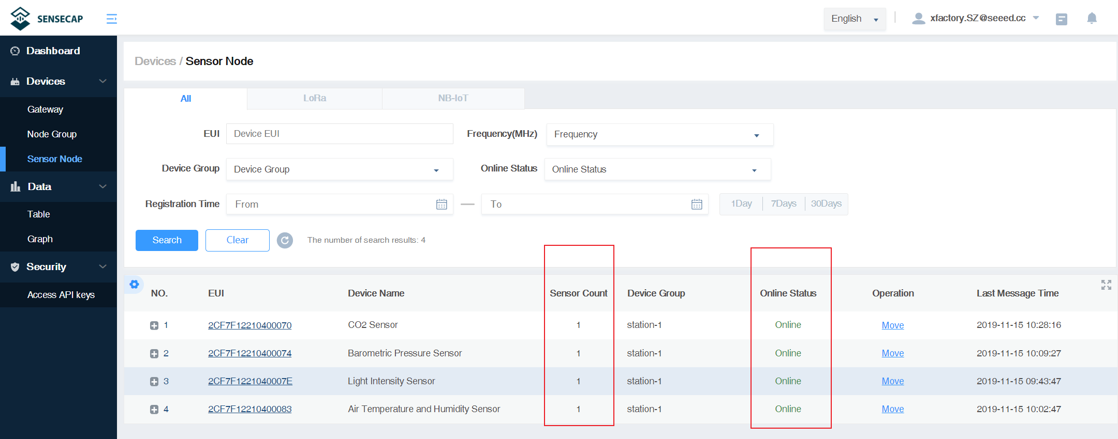

① Sensor Count, If the display is 0, it means that the network access is abnormal, and the sensor needs to be restarted to enter the network again. Greater than 0 means normal.

② Online Status, “online” or “offline”.

|  |
| --- |
| **Note:** After joining the network, the Sensor Count must be greater than 0, otherwise the node cannot use functions such as data charts. If it is 0, use the "RESET" button of the node to re-enter the network and return to normal. |

# SenseCAP Portal

The main function of the SenseCAP Portal is to manage SenseCAP devices and to store data. It is built on Azure, the secure and reliable cloud service from Microsoft. You can apply for an account and bind all devices to this account. SenseCAP provides the web portal and API. The web portal includes Dashboard, Device Management, Data Management and Access Key Management, while API is open to users for further development.

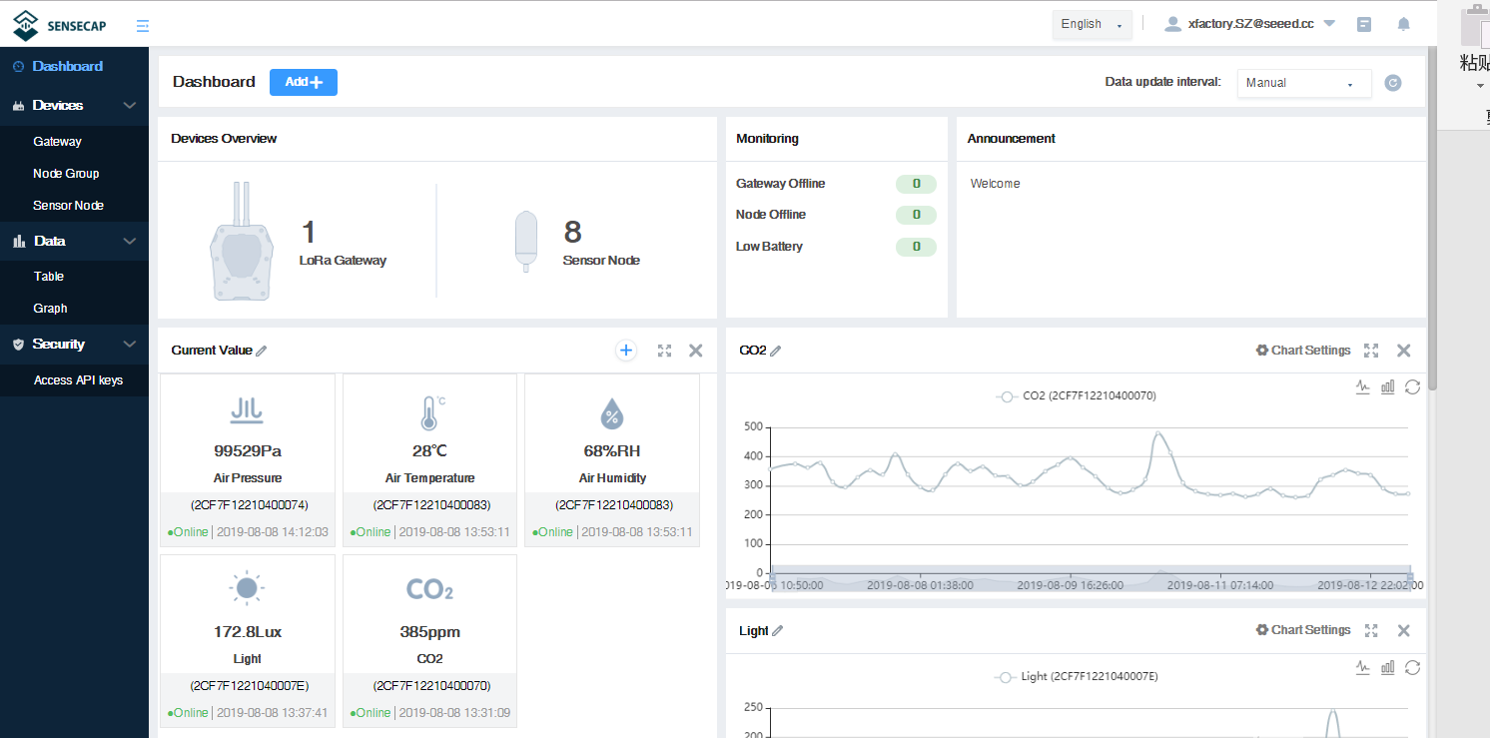

## Explanation of Terms and Tags

|  |  |
| --- | --- |
| **Term** | **Explanation** |
| EUI | The unique identifier for each SenseCAP device |
| Access Key | The key for accessing API |
| Cloud Service | The general term that includes a series of services: cloud platform, API, and App, etc. |
| Dashboard | The interface that monitors and displays data |
| SenseCAP App | The iOS/Android tool that binds the devices to your account. |

* **Sensor Node Tags**

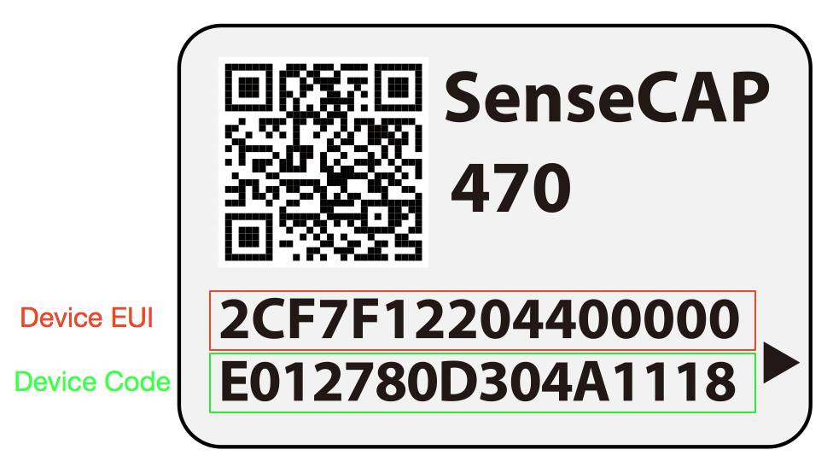

① Device EUI: As the unique encoding of the identification device, each EUI is unique.

② Device Code: Information encoding for device binding, network access, etc.

## Account and Login

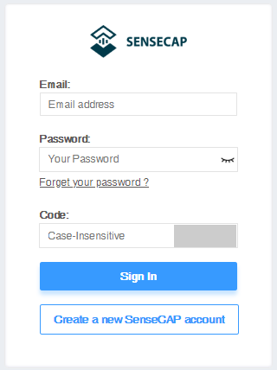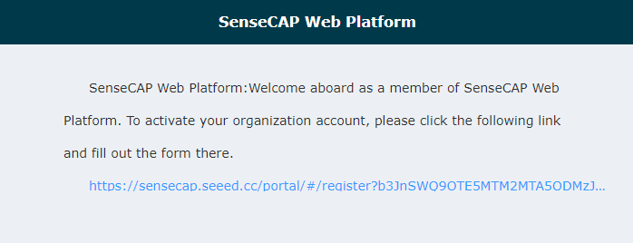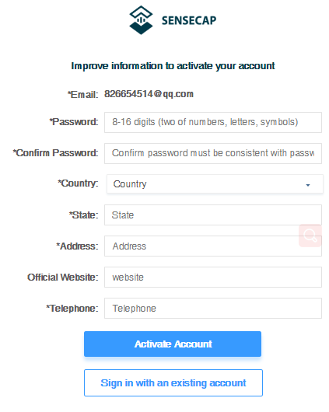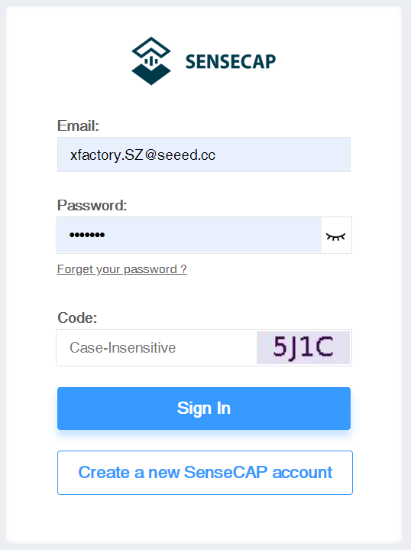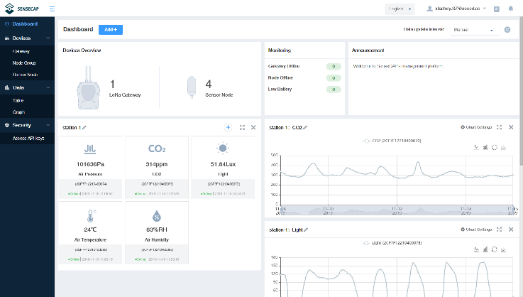

**Portal Website:** [http://sensecap.seeed.cc](http://sensecap.seeed.cc/)

① Select register account, enter email information and click "register", the registered email will be sent to the user's mailbox.

② Open the "SenseCAP…"Email, click the jump link, fill in the relevant information, and complete the registration.

③ Return to the login interface and complete the login.

|  |
| --- |
| **Note:** If you can't find the email, it may be automatically identified as "spam" and put in the "trash can". |

* **Password Retrieval**

If you forget your password when logging in, you can retrieve it through your email.

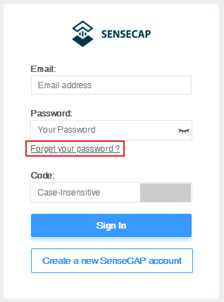

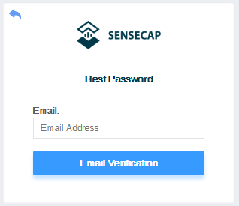

## Dashboard

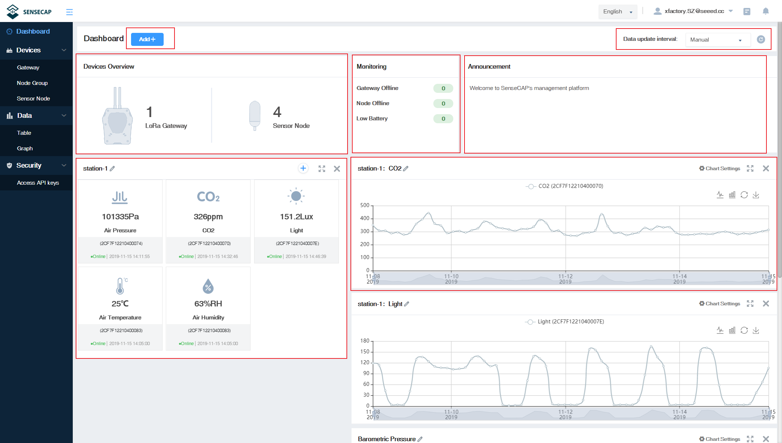

① Add “Scene” or “Chart”.

② Devices Overview: displays the total number of devices.

③ Monitoring: count all offline devices and low power devices.

④ Data update interval: sets how and at what time the page (web page) is refreshed.

⑤ Announcement: prompt for portal version upgrade and other information.

⑥ Scene: the corresponding visual display module is configured according to the sensor area.

⑦ Chart: one or more sensors of the same type can be selected to display historical data over a period of time.

### Configure Scene

According to the installation site or application scenario, you can choose to create scene data, by grouping different data and show the latest data in the form with icons.

Example: There are several groups under the account: station-1, station-2, station-3…Create a scene for station-1.

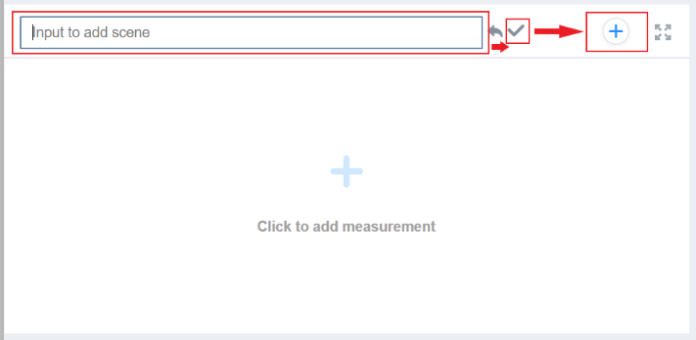 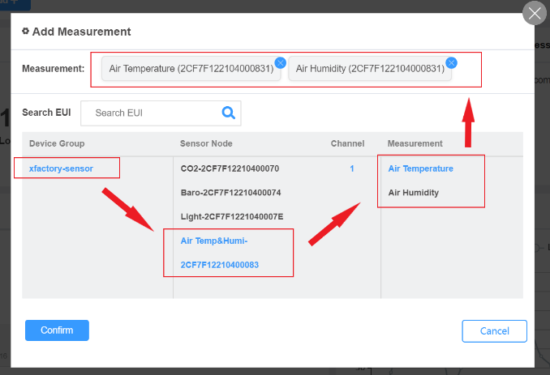

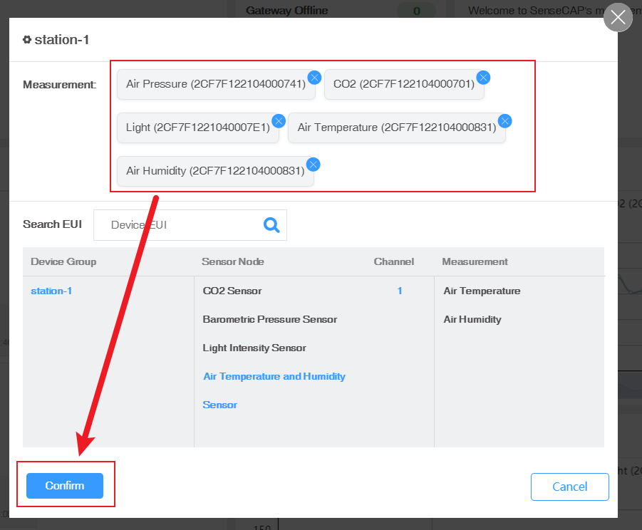 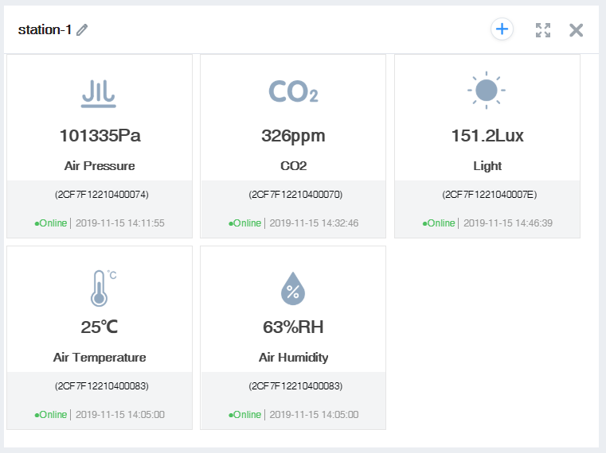

① Customize the name, create the scene display of "station-1", and select “Add measurement type”.

② Select the measurement data to be displayed under the group of "station-1" and confirm.

### Configure Charts

You can create charts to show the info such as measurement type, device EUI, and time range etc.

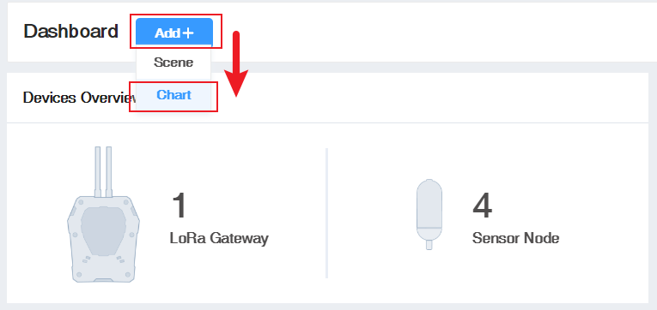 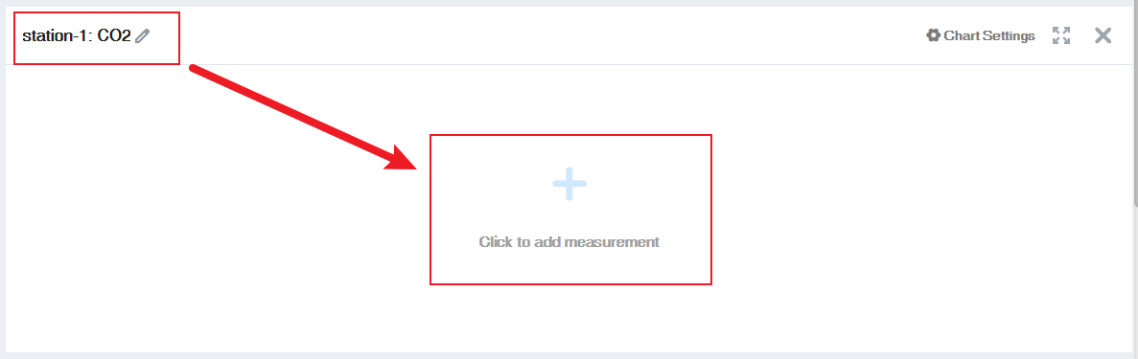

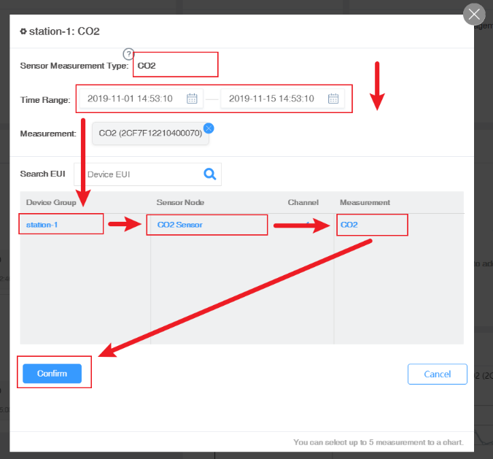





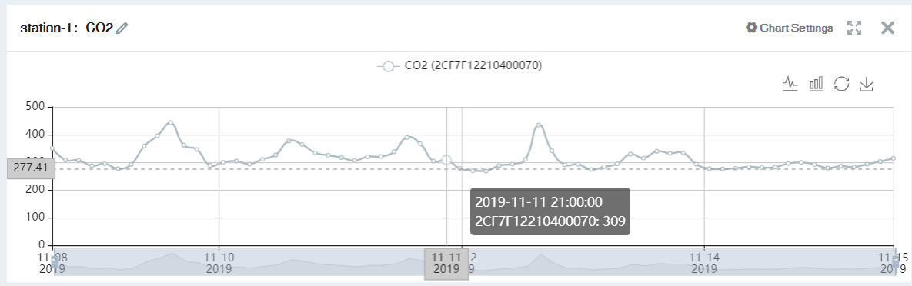

① Select “Add”- “Chart”. ② Customize the name and select “add measure type".

③ Select the data type and time period to display. ④ Select group.

⑤ Select the specific sensor node under the group. ⑥ Select the measurement type.

⑦ Confirm.

|  |
| --- |
| **Note:** Only one measurement type can be added per chart. Add up to 5 curves per chart. |

## Device Management

Here you are offered several methods to manage SenseCAP devices, including Gateway Management, Node Group Management, and Sensor Node Management.

### Gateway

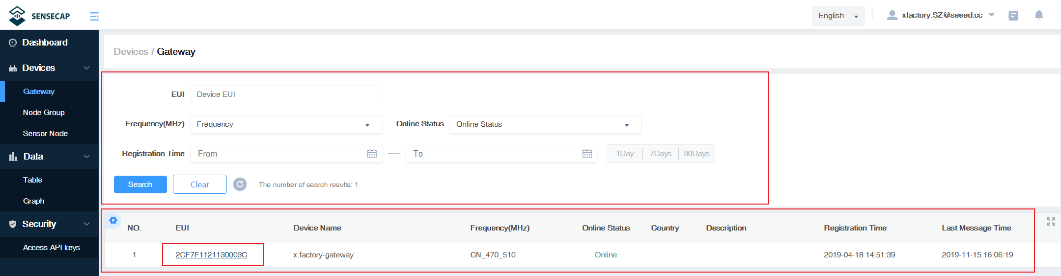

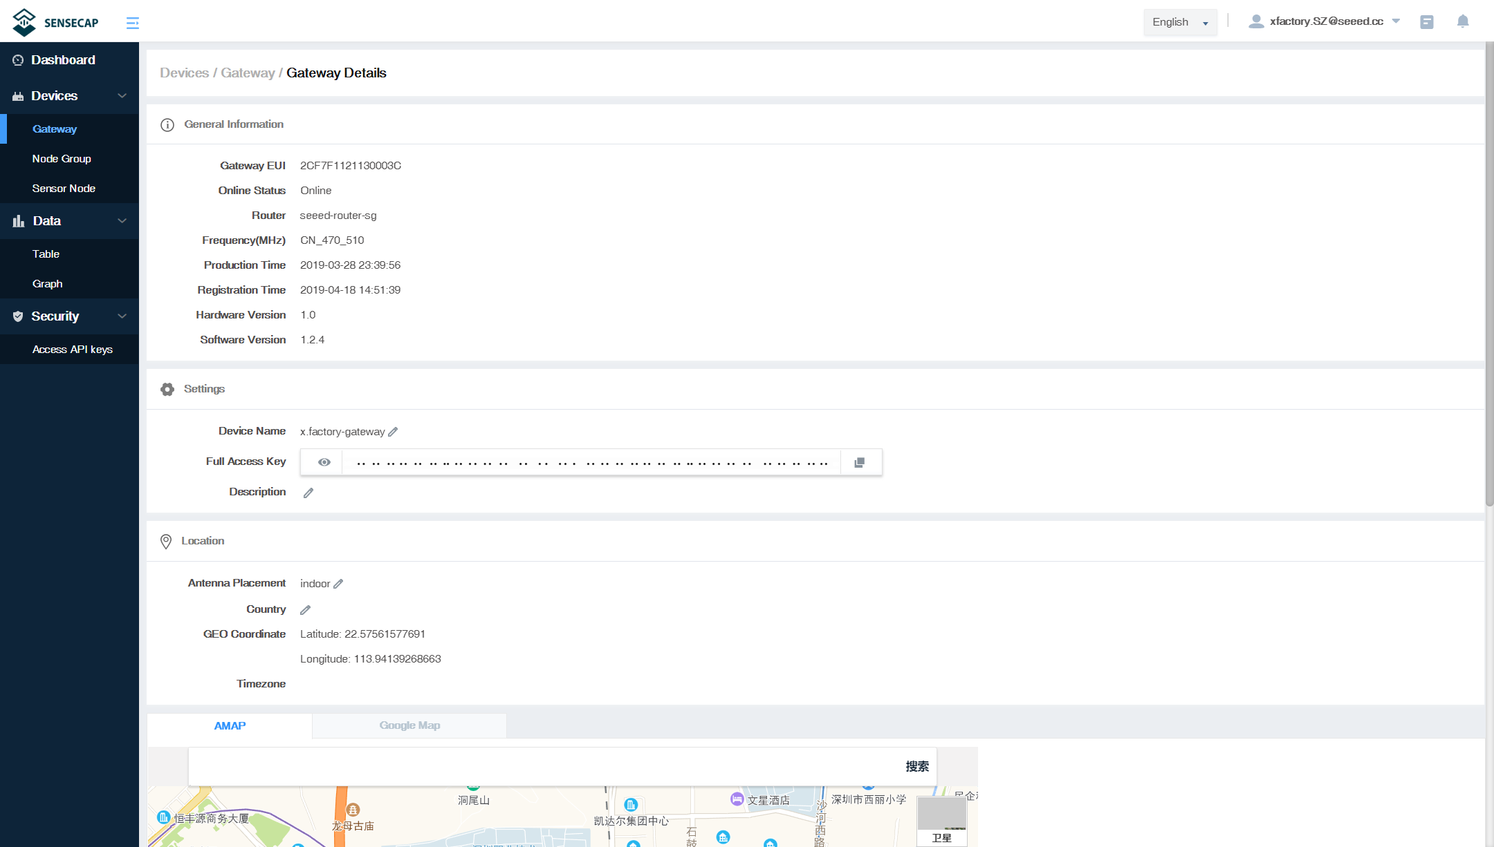

① Filter the gateway based on EUI, frequency, status, and registration time.

② List of gateways, displaying EUI, name, status, and so on.

③ Click EUI to enter the device details page to view basic information, location, etc.

### Node Group Management

You can manage devices conveniently by groups. You can create new groups, delete groups or move devices to a certain group.

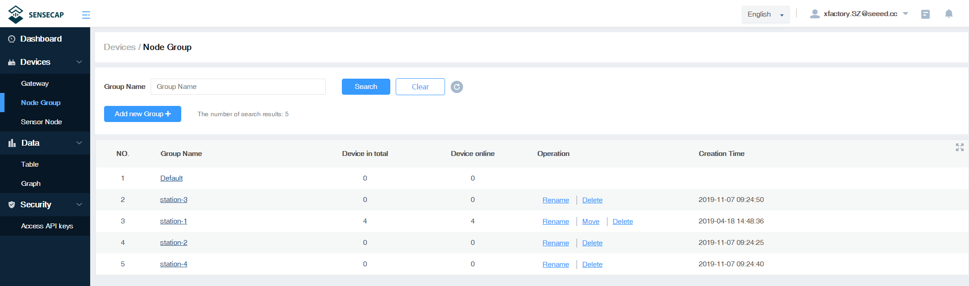

### Sensor Node Management

At the page of Sensor Node, you can see all the Sensor Nodes bound to your account.

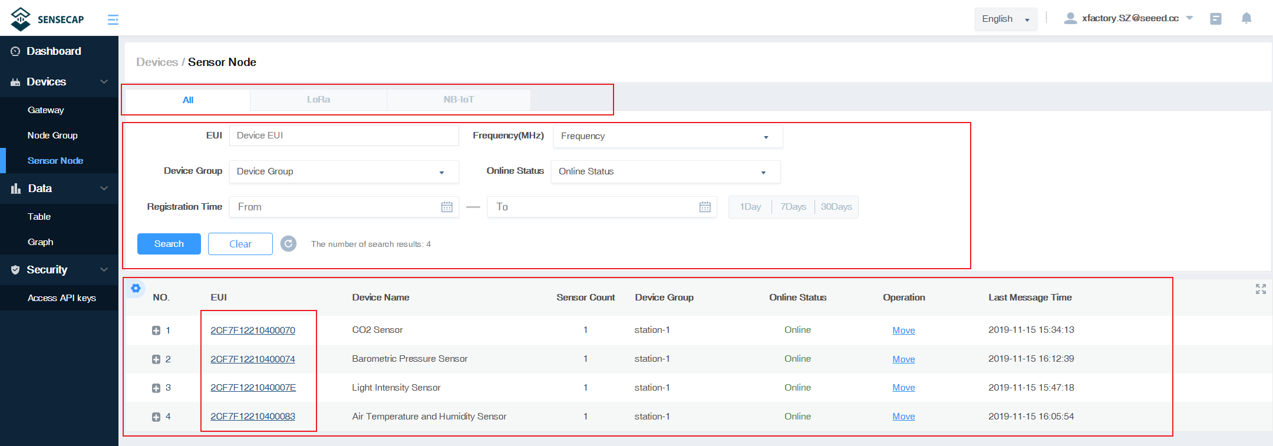

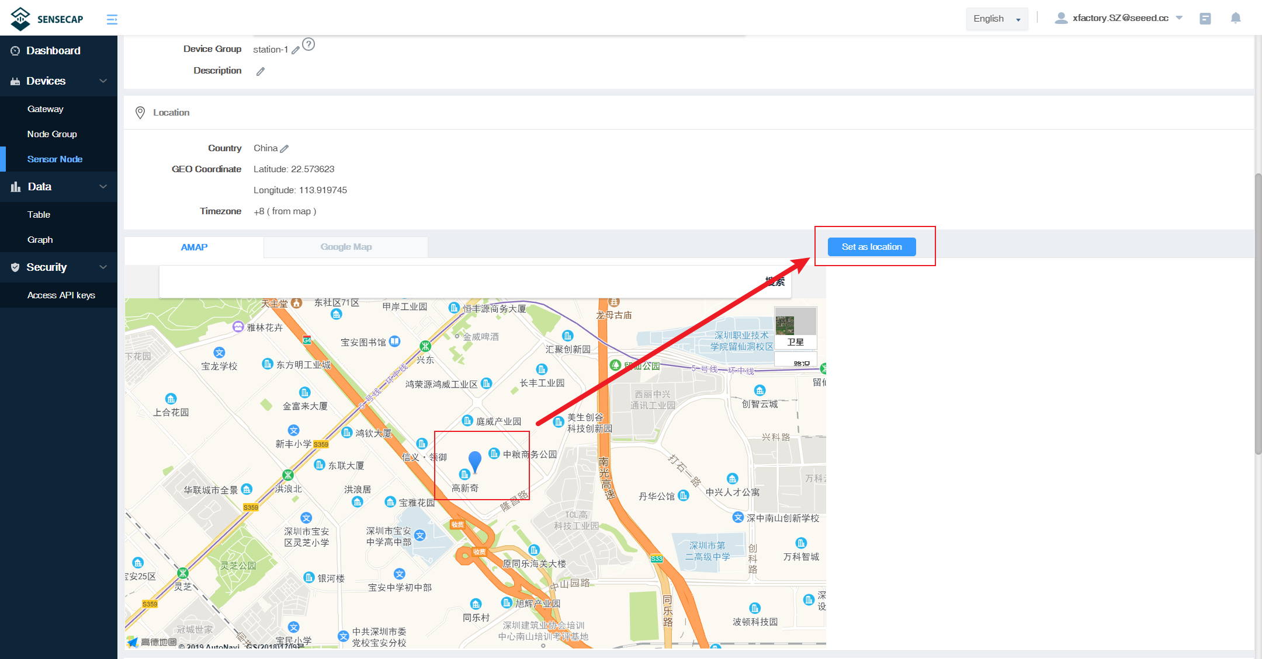

① Devices contain types such as "LoRa" and "NB-IoT" and can be viewed by category.

② Filter criteria, according to EUI, frequency, group, status, registration time filter node.

③ Sensor Node list, displaying EUI, name, status, data type, and so on.

④ Click EUI to enter the device details page and view the basic information of the Sensor Node.

⑤ Click the coordinates of the map to set the positioning of the Sensor Node.

## Data Management

* **Table**

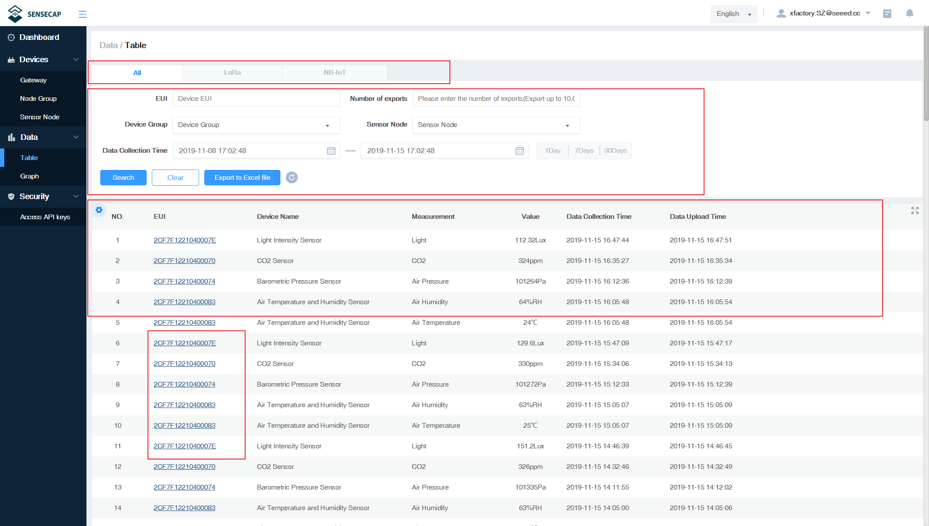

① Devices contain types such as "LoRa" and "NB-IoT" and can be viewed by category.

② Filter criteria, according to EUI, frequency, group, status, registration time filter node.

③ List of data showing EUI, device name, data type, measurements, collection and upload time, etc.

④ Click EUI to enter the device details page and view the basic information of the Sensor Node.

* **Graph**

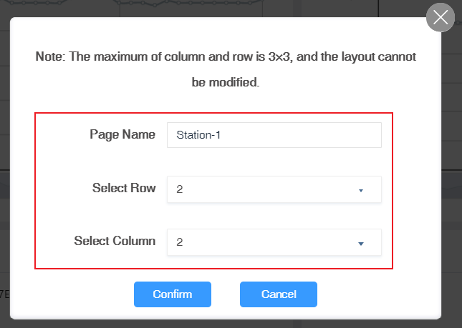

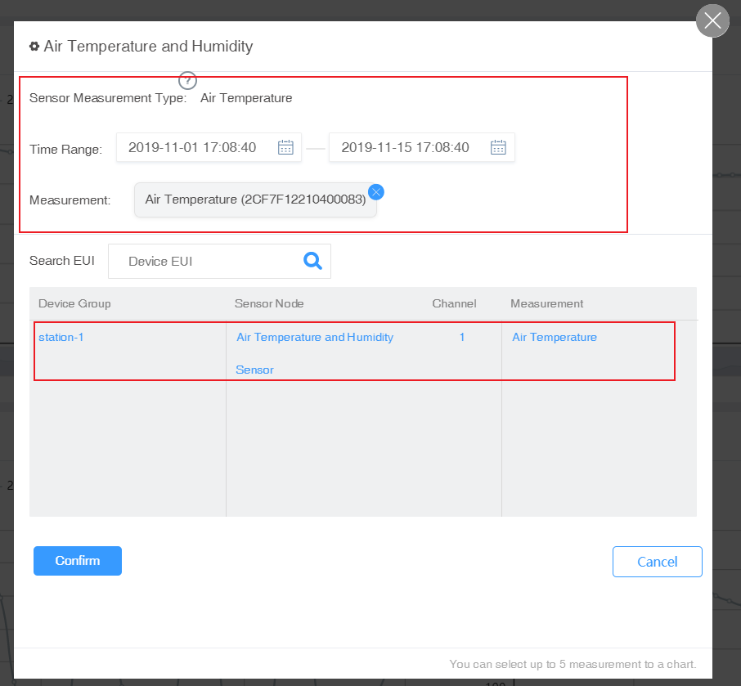

① Add a new page, enter a page name, and select the number of rows and columns.

② Select the measurements and time intervals to be displayed.

③ Select specific sensor data.

|  |
| --- |
| **Note:** Up to three rows and three columns can be set per page, and multiple pages can be created. Please refer to Dashboard chart for detailed steps. |

## Security

### Check Account Info

In Account Management page, you can check your account info and click to change the info.

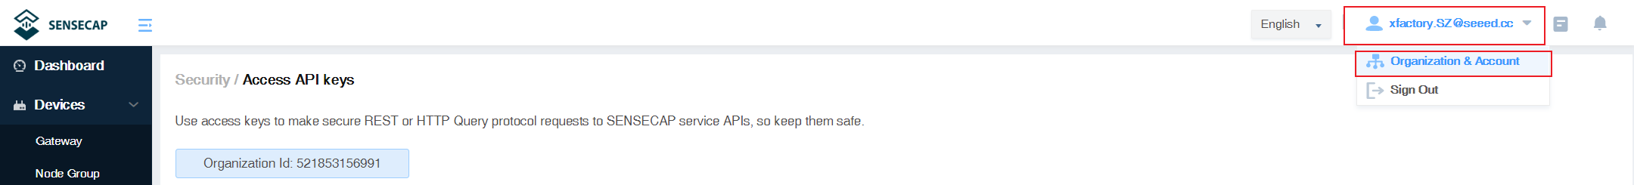

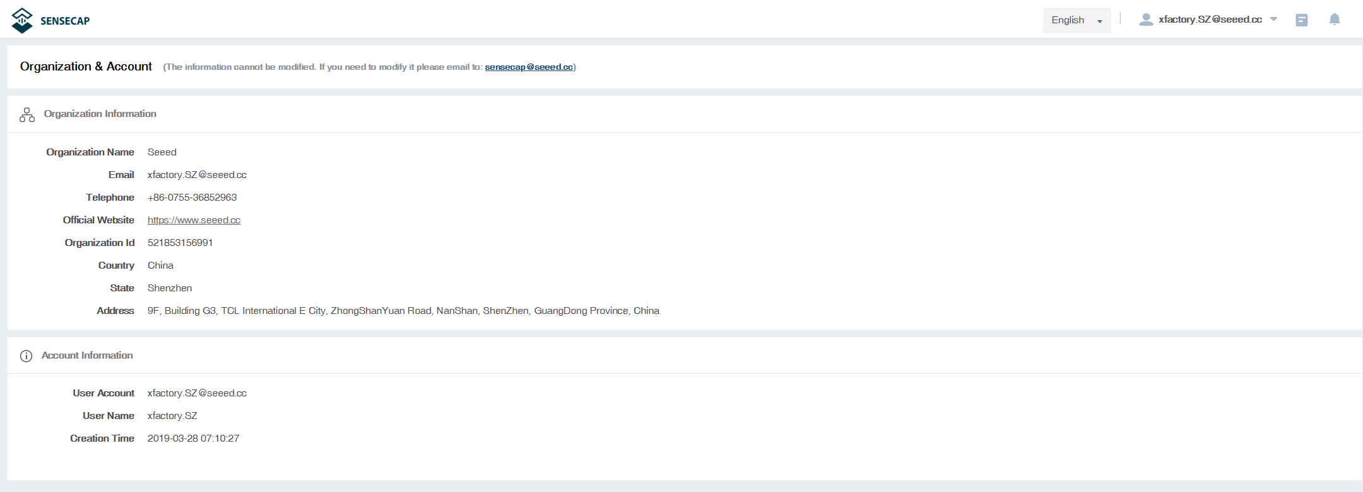

### Access Key Management

Access Key is used for accessing API. And Security Credentials provides functions such as “Create”, “Update”, and “Check” for you to manage Access Key.

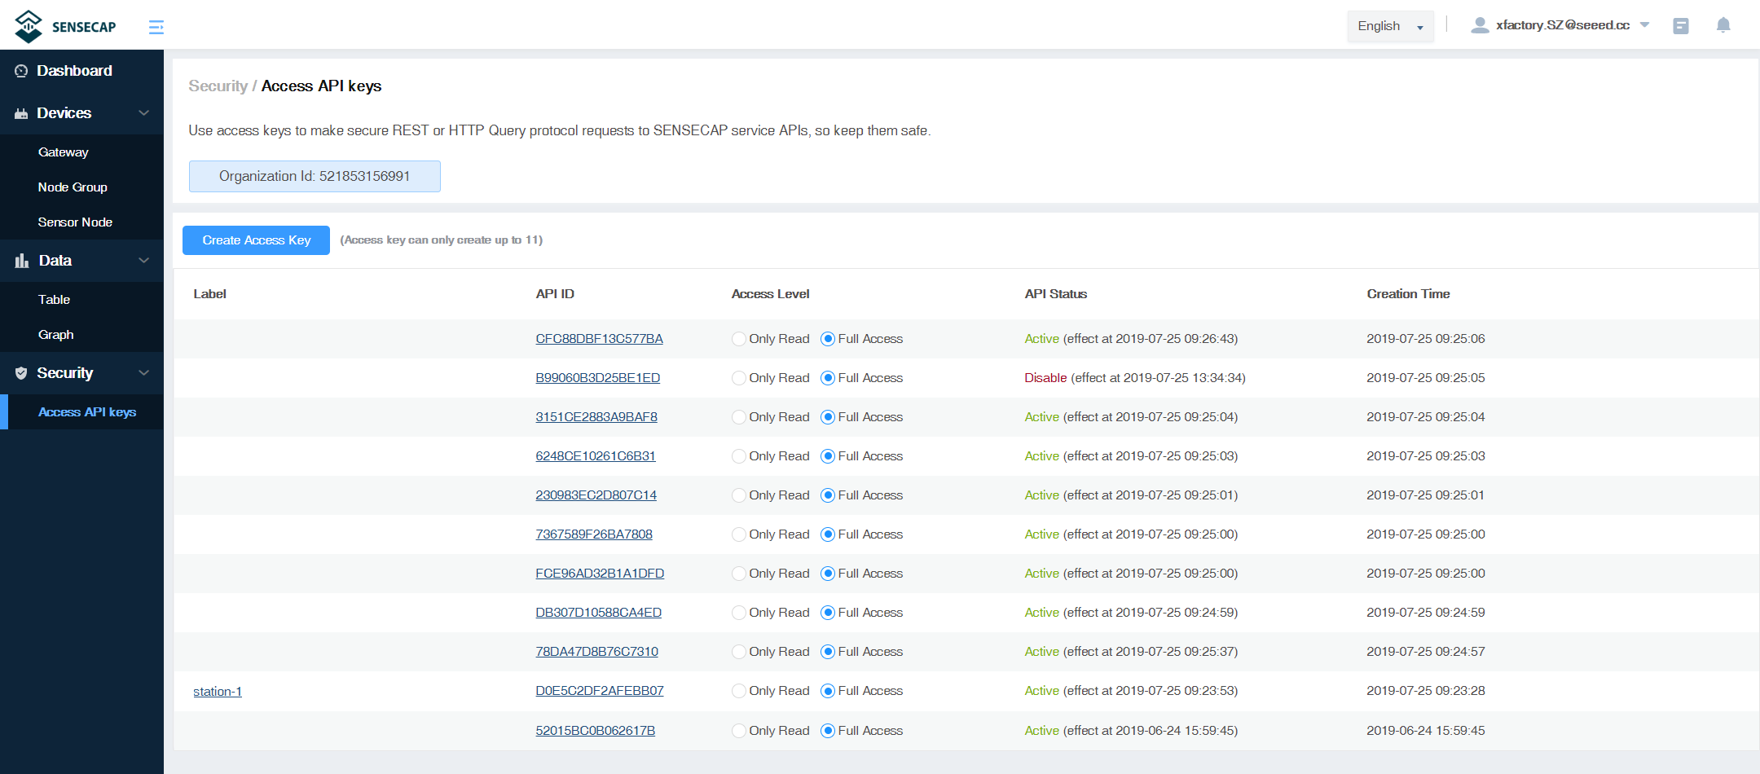

# SenseCAP App Instructions

As a tool, SenseCAP App is used to bind devices to your account and check device basic info.

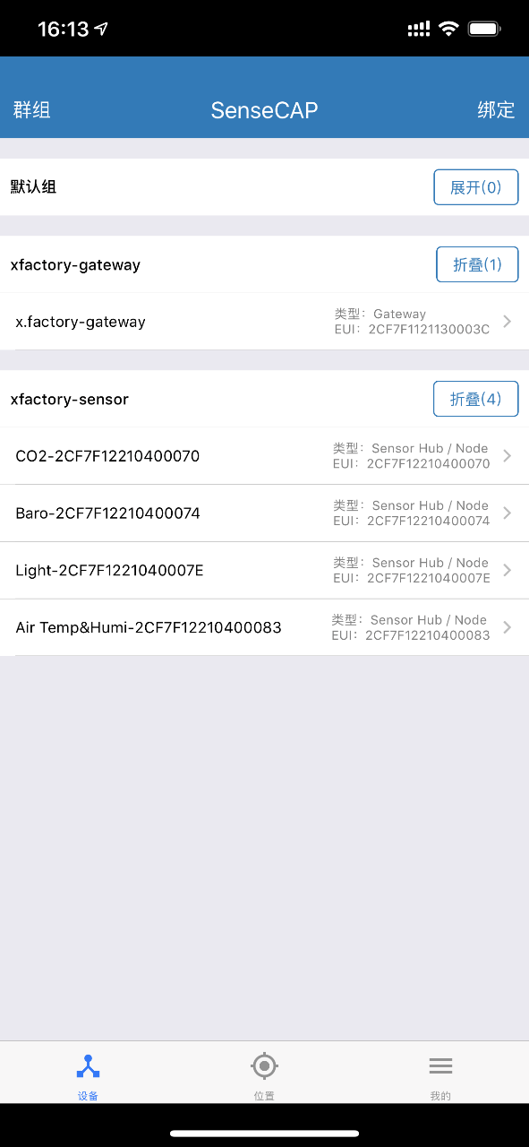

## Download SenseCAP App

* For iOS, please search for “SenseCAP” in Apple Store and download.

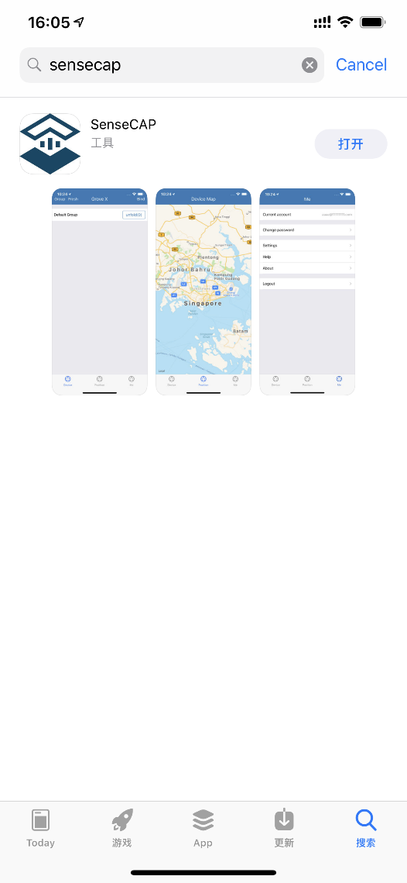

* For Android, you can download the App from <https://www.pgyer.com/sensecap>

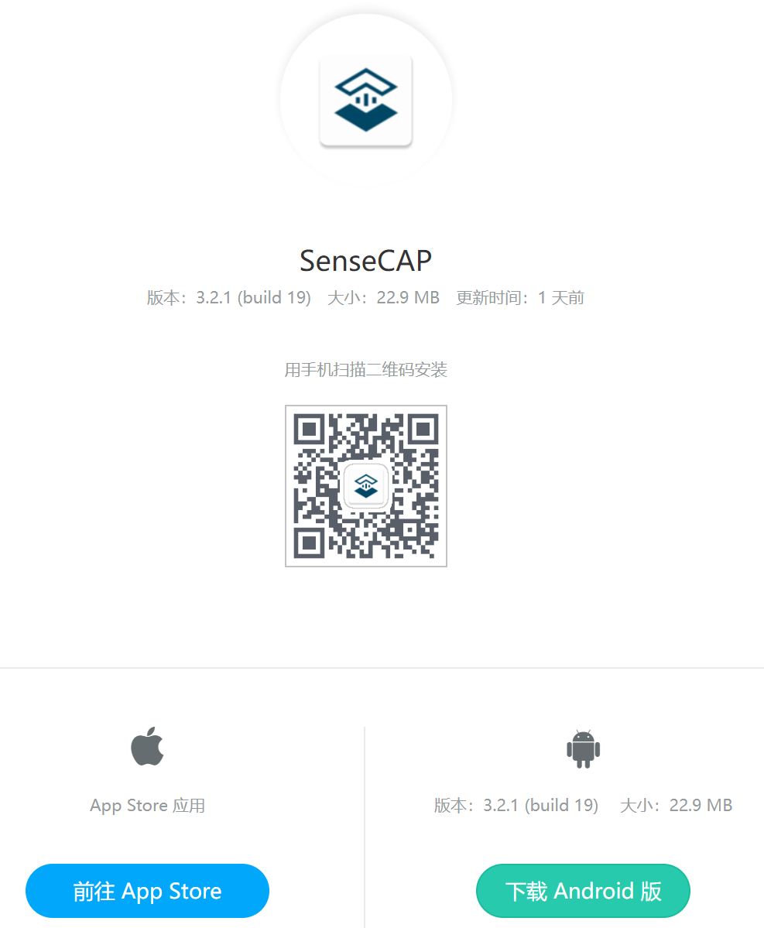

## Bind Devices

* Scan QR Code

Click “Bind” on the upper-right corner to enter the device binding page.

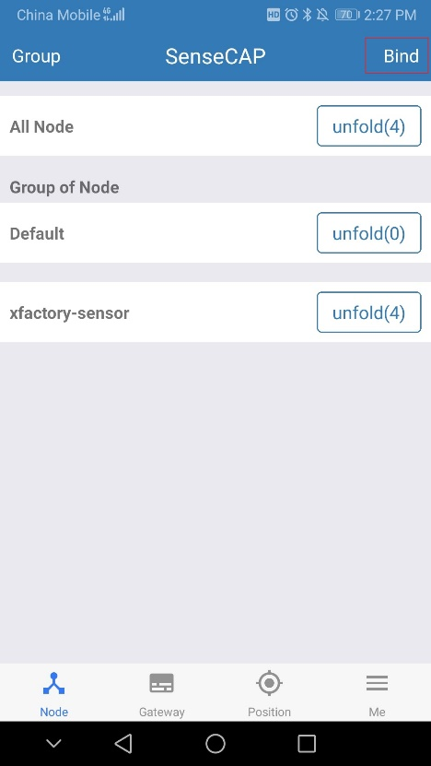

Scan the QR code on the device to bind the device to your account. If you do not set it to a designated group, the device will be put into the “default” group.

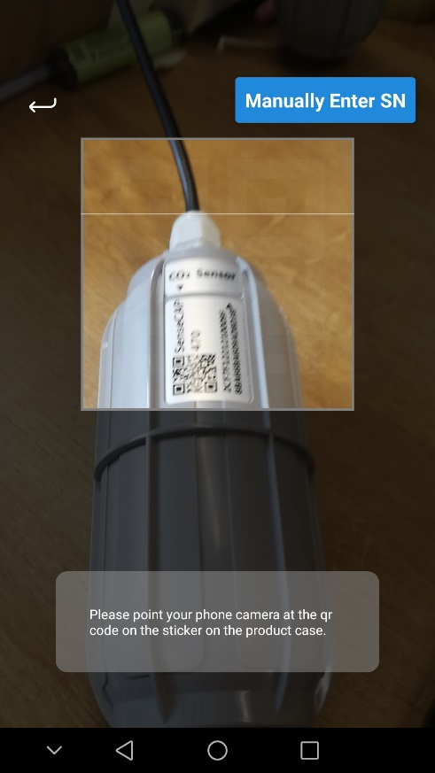

* Manually fill in the EUI

If the QR code sticker is damaged, you can manually fill in the EUI of the device to bind the device to your account. Please make sure you put in the EUI in the format suggested by the system, and then click “confirm”.

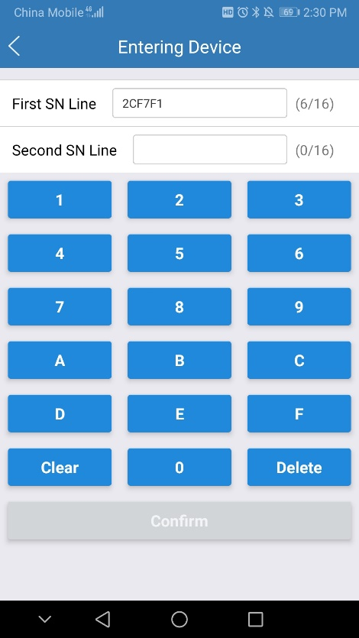

### Group Management

### Check Groups

Click “Group” on the upper-left corner to check the list of Groups and manage Groups.

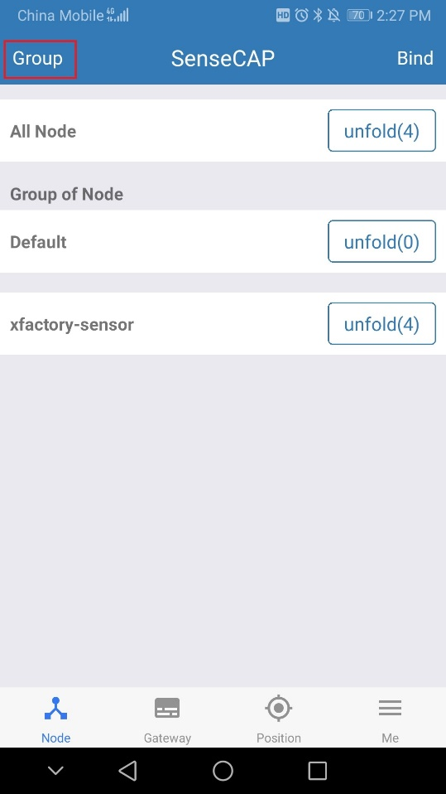 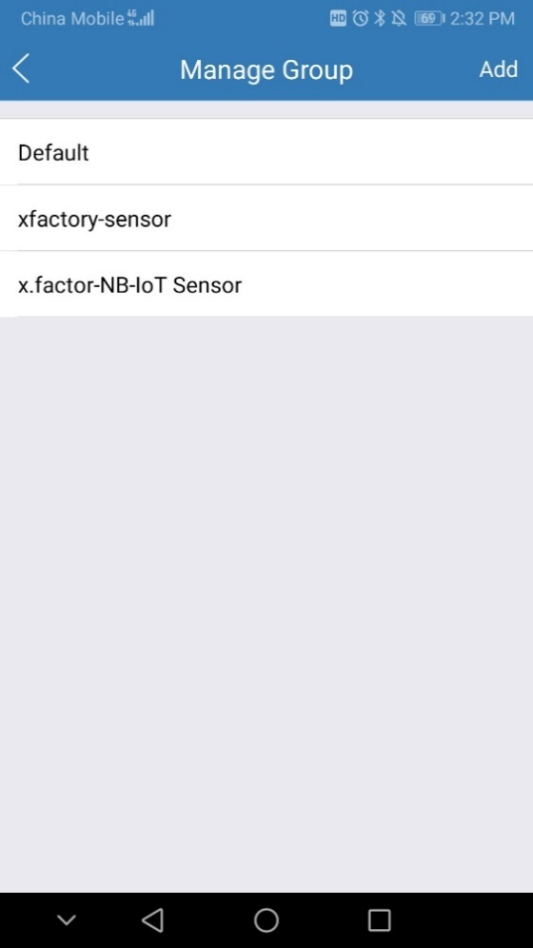

### Create New Groups

On the upper right corner, click “Create” to add a new Group, fill in the group name, click “Confirm”.

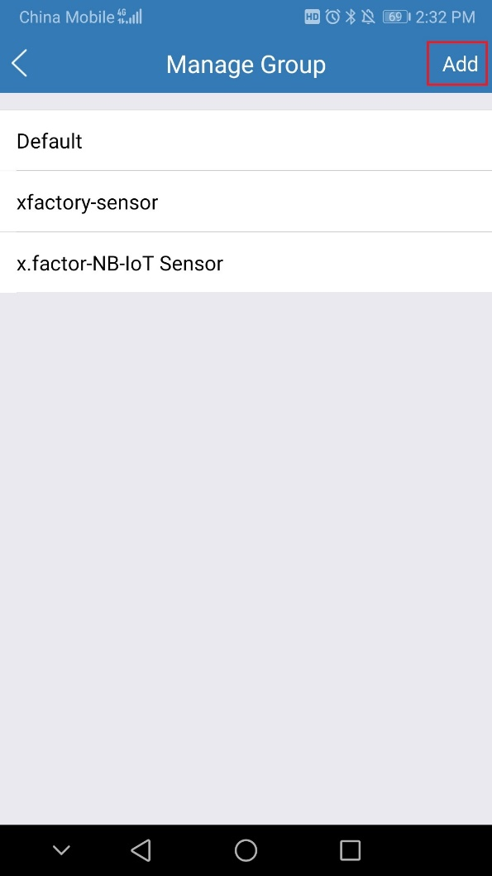 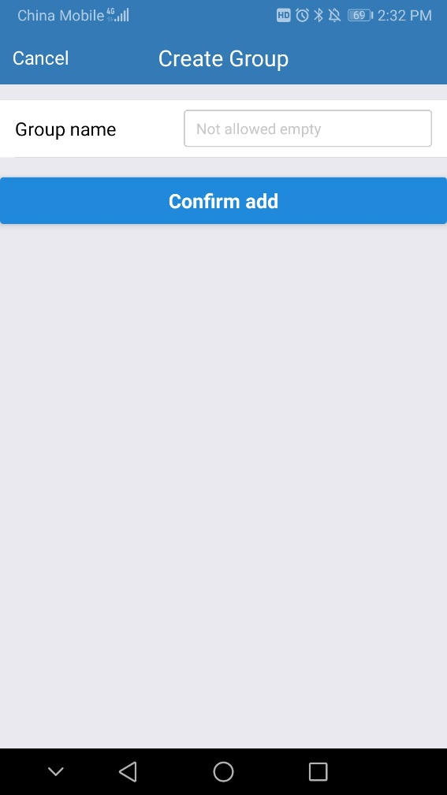

## Device Management

### Check Device

On SenseCAP App homepage, the devices are shown in Groups. You can click “Unfold” to show the devices in respective Groups. The info shown here includes device name, type, and EUI.

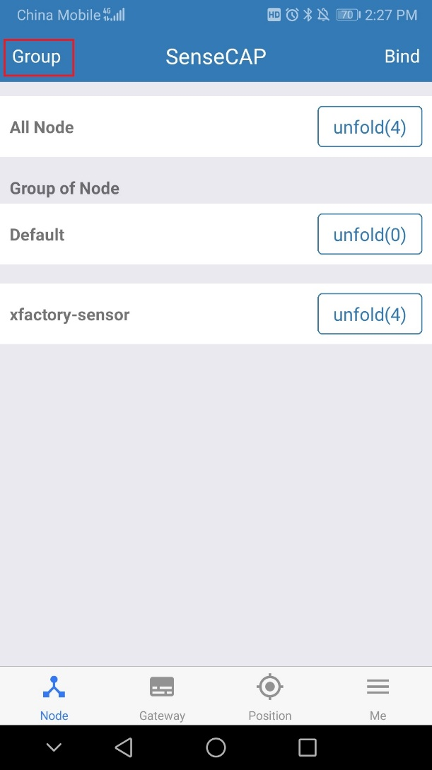 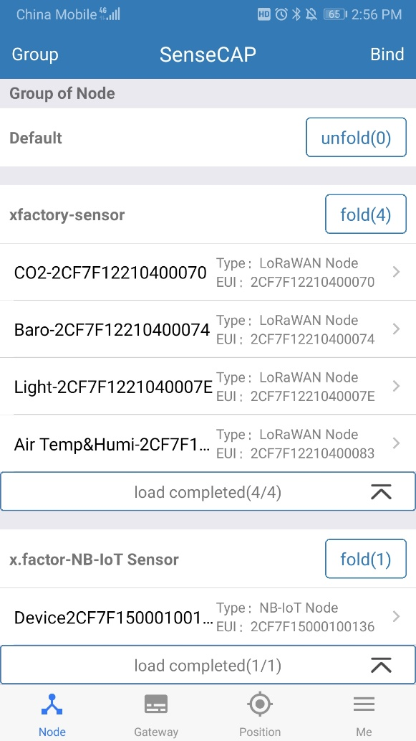

### Device Details

Click device name to enter its respective page, showing device name, type, EUI, status, time of the latest message and 10 recent RAW messages.

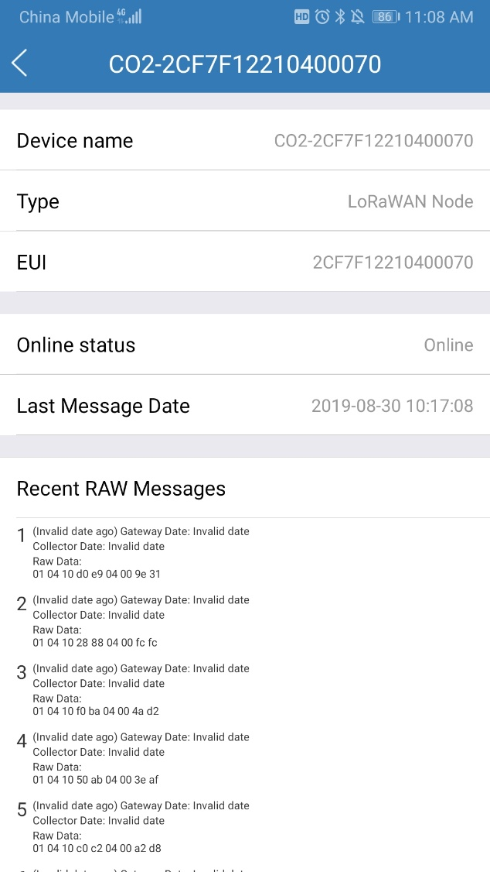

## User Profile

### Check Current Account

At “My Profile” page, you can check the current account.

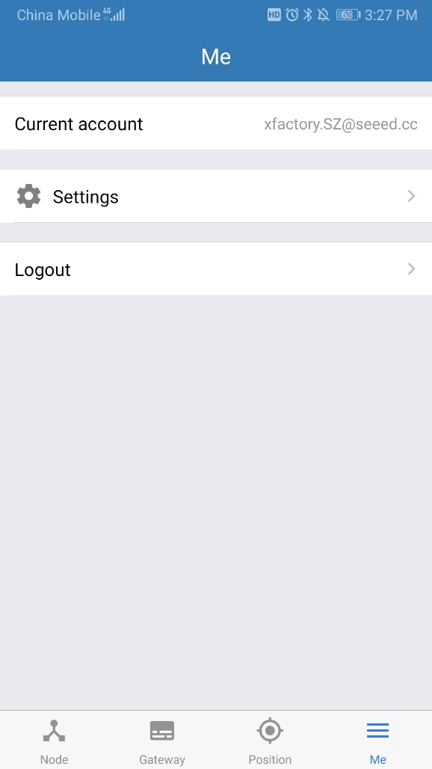

### Settings

You can change map service provider based on the actual needs in the local areas where you deploy the solution.

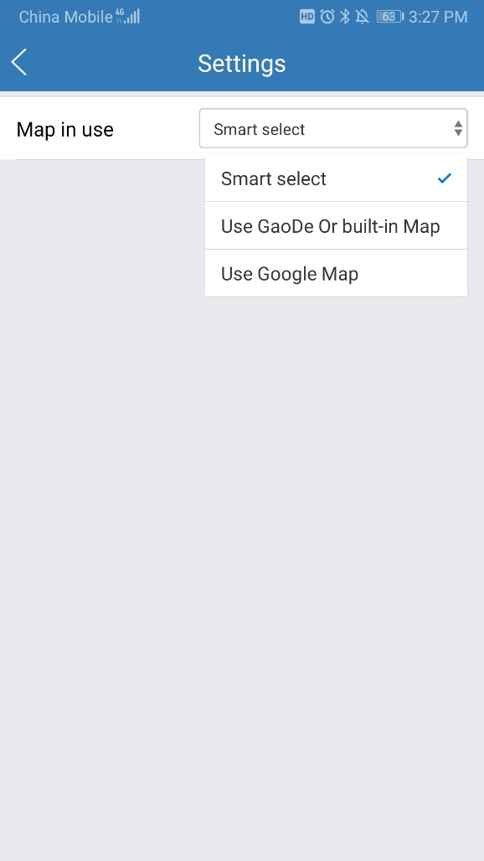

### Sign Out

Click “Sign Out” to log out of your current account.

# API Instruction

SenseCAP API is for users to manage IoT devices and data. It combines three types of API methods: HTTP protocol, MQTT protocol and Websocket protocol.

* With HTTP API, users can manage LoRa and NB-IoT devices, to get RAW data or historical data.
* With MQTT API, users can subscribe to the sensor's real-time measurement data through the MQTT protocol.
* With Websocket API, users can get real-time measurement data of sensors through Websocket protocol.

Please refer to this link for API User Guide: <https://sensecap.gitbook.io/doc/>

